https://explore.skillbuilder.aws/learn/course/161/play/36138/getting-started-with-amazon-simple-storage-service-amazon-s3;lp=82

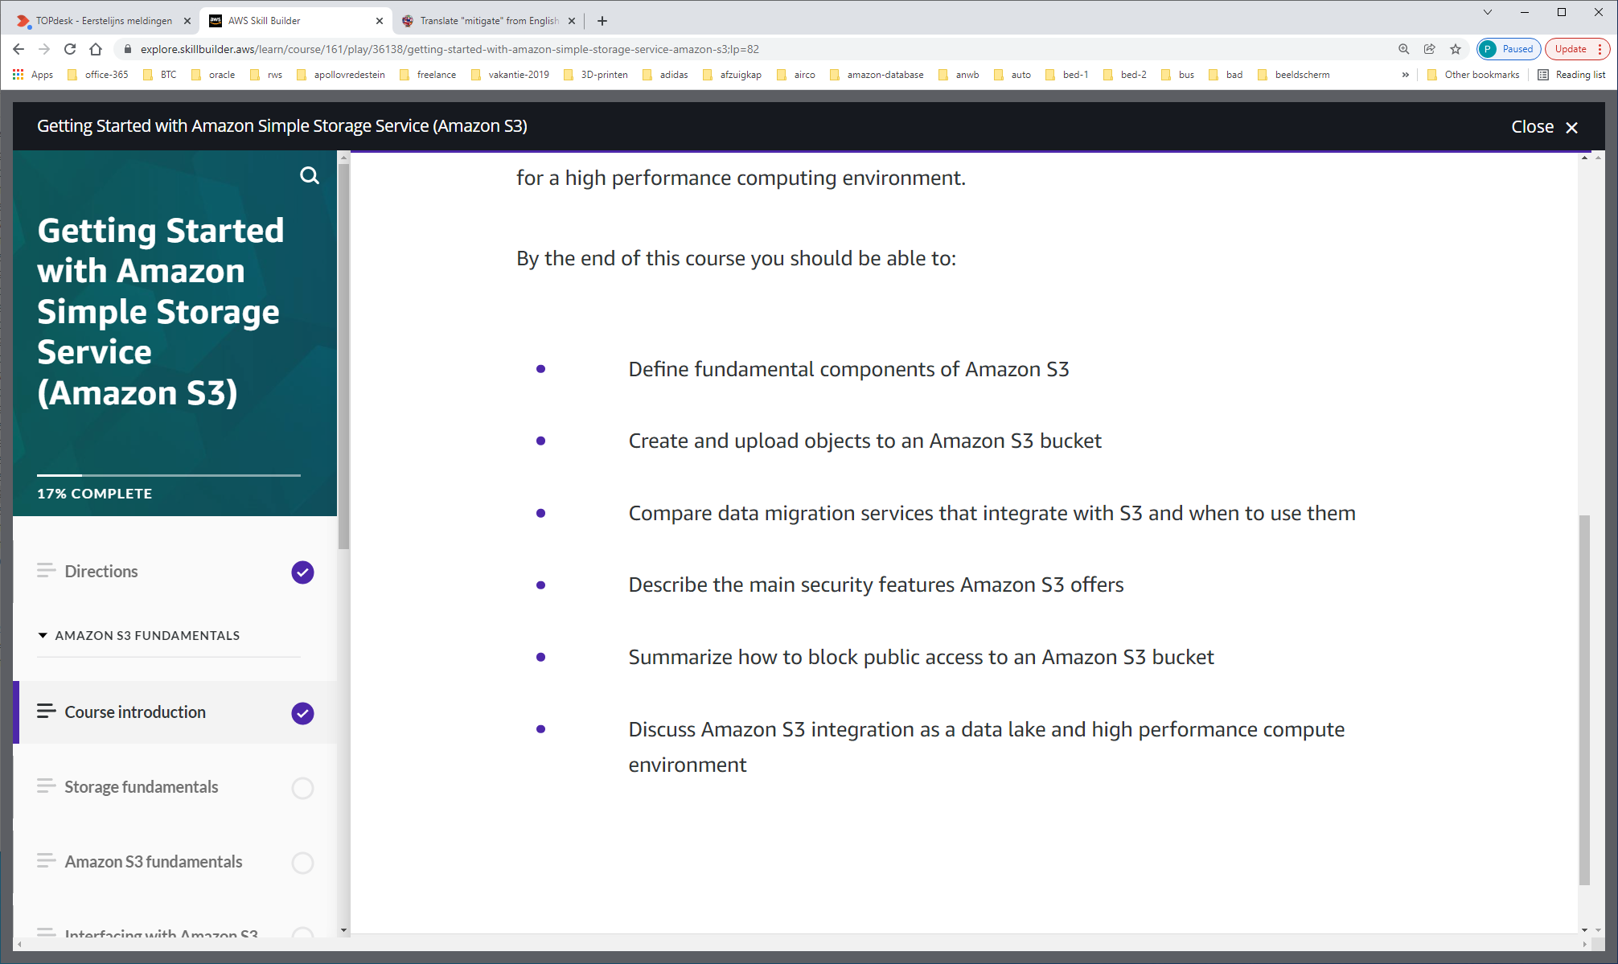

Amazon S3 is storage for the Internet that makes web-scale computing easier for developers and users alike.  Amazon S3 is an object storage platform that allows you to store and retrieve any amount of data, at any time, from anywhere on the web.  If you are new to storage, you may not be aware that there are different types of storage.

Amazon S3 is an object storage based service. However, to better understand object storage and how it differs from the other storage types, take a moment to review the underlying differences between storage types.

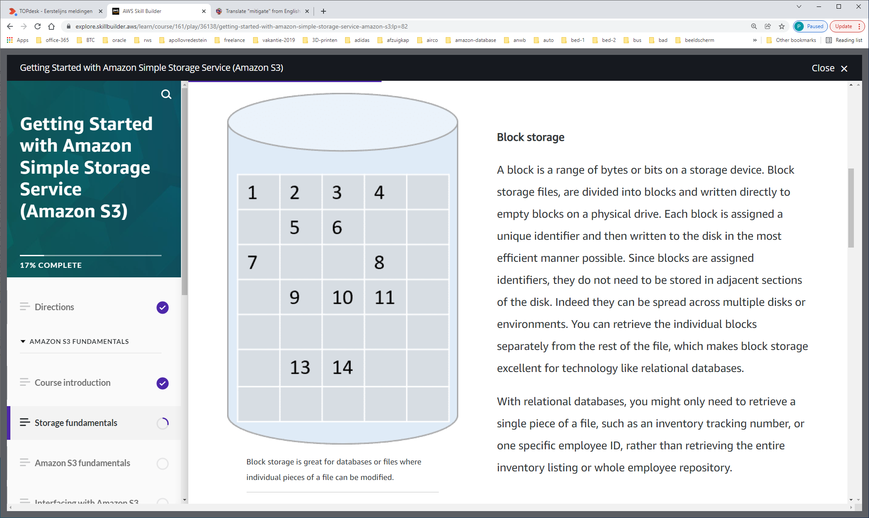

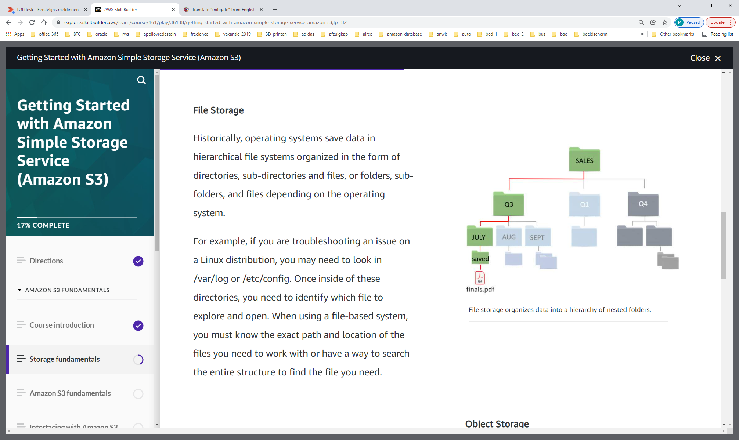

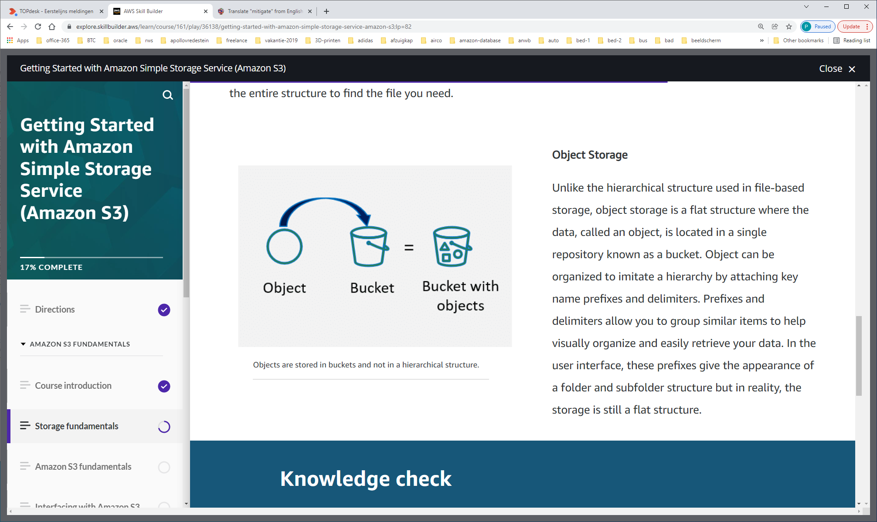

Prefixes and delimiters allow you to group similar items to help visually organize and easily retrieve your data

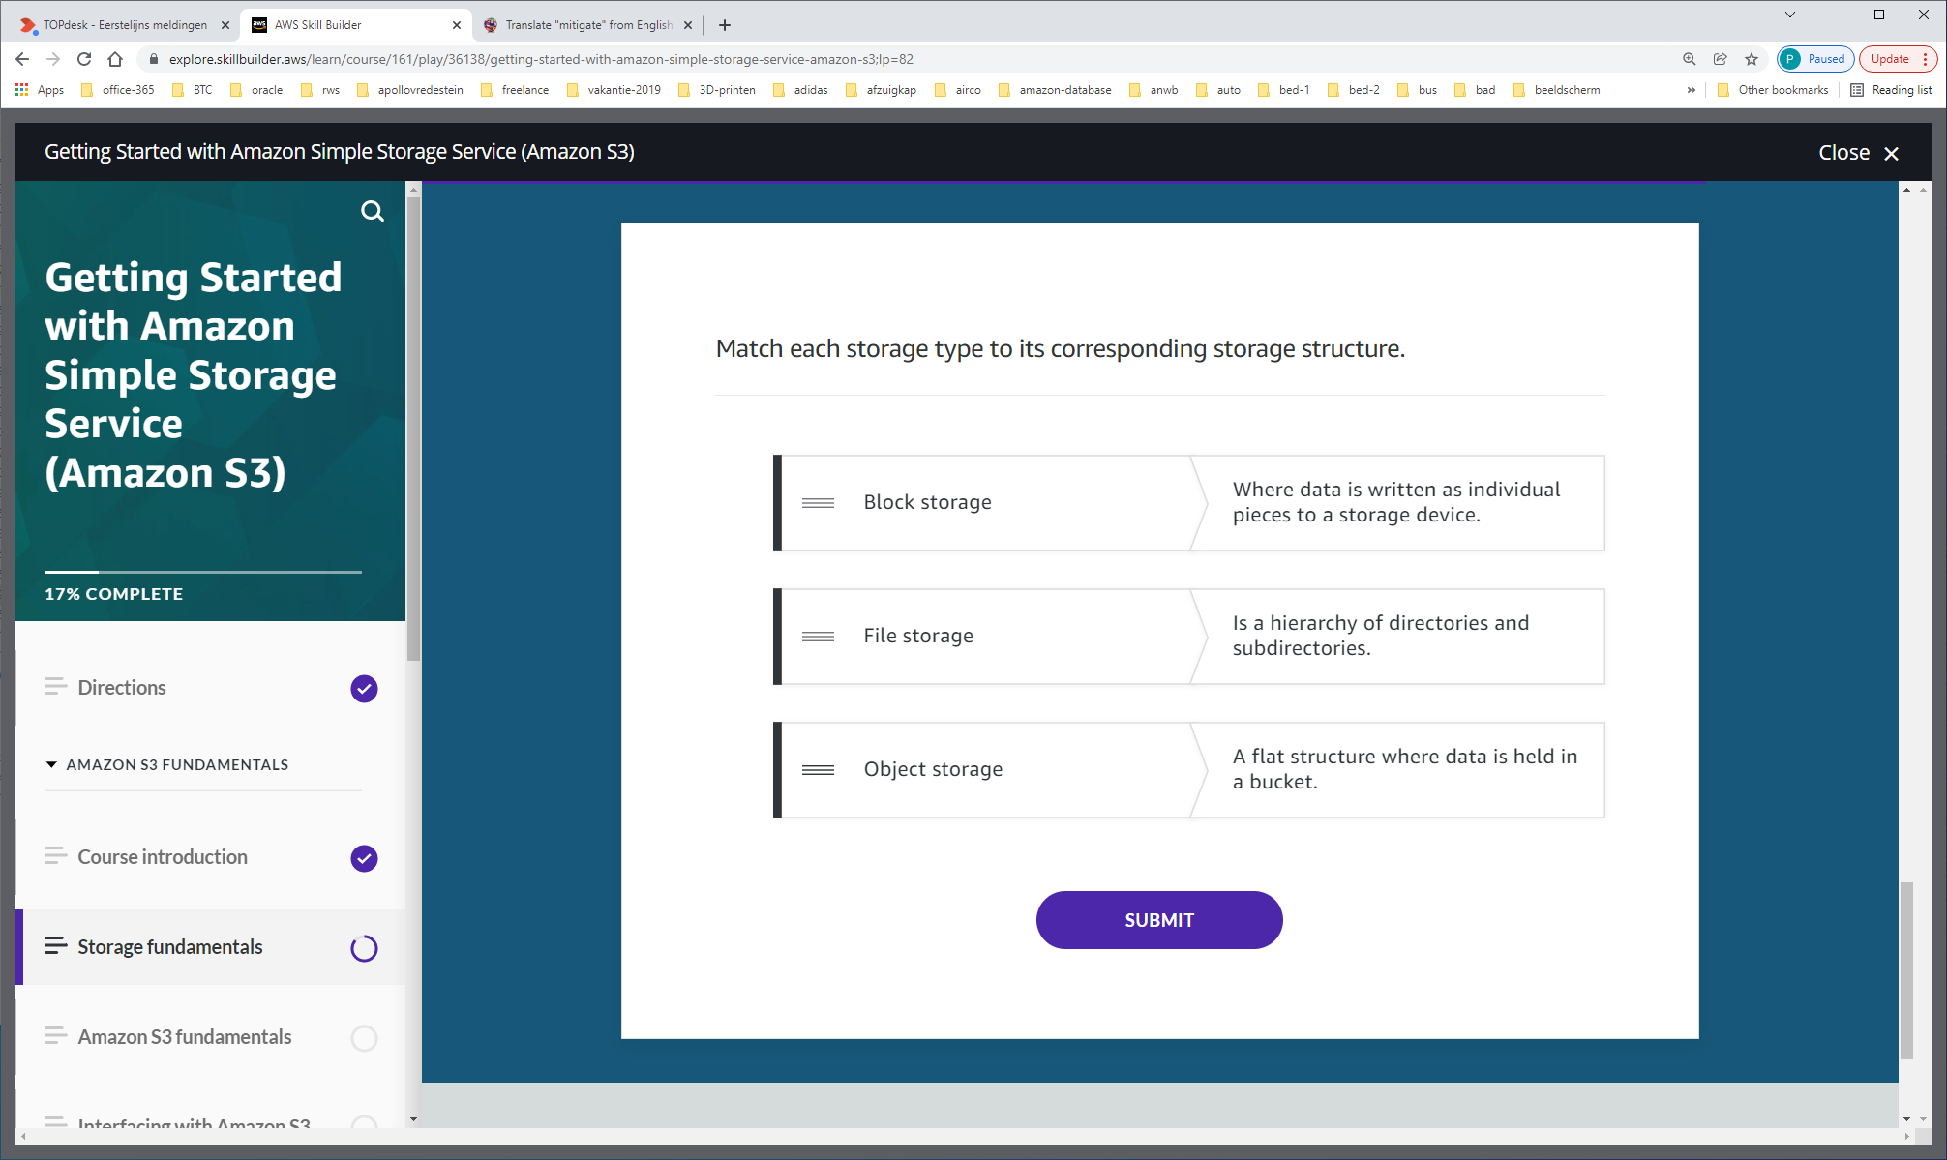

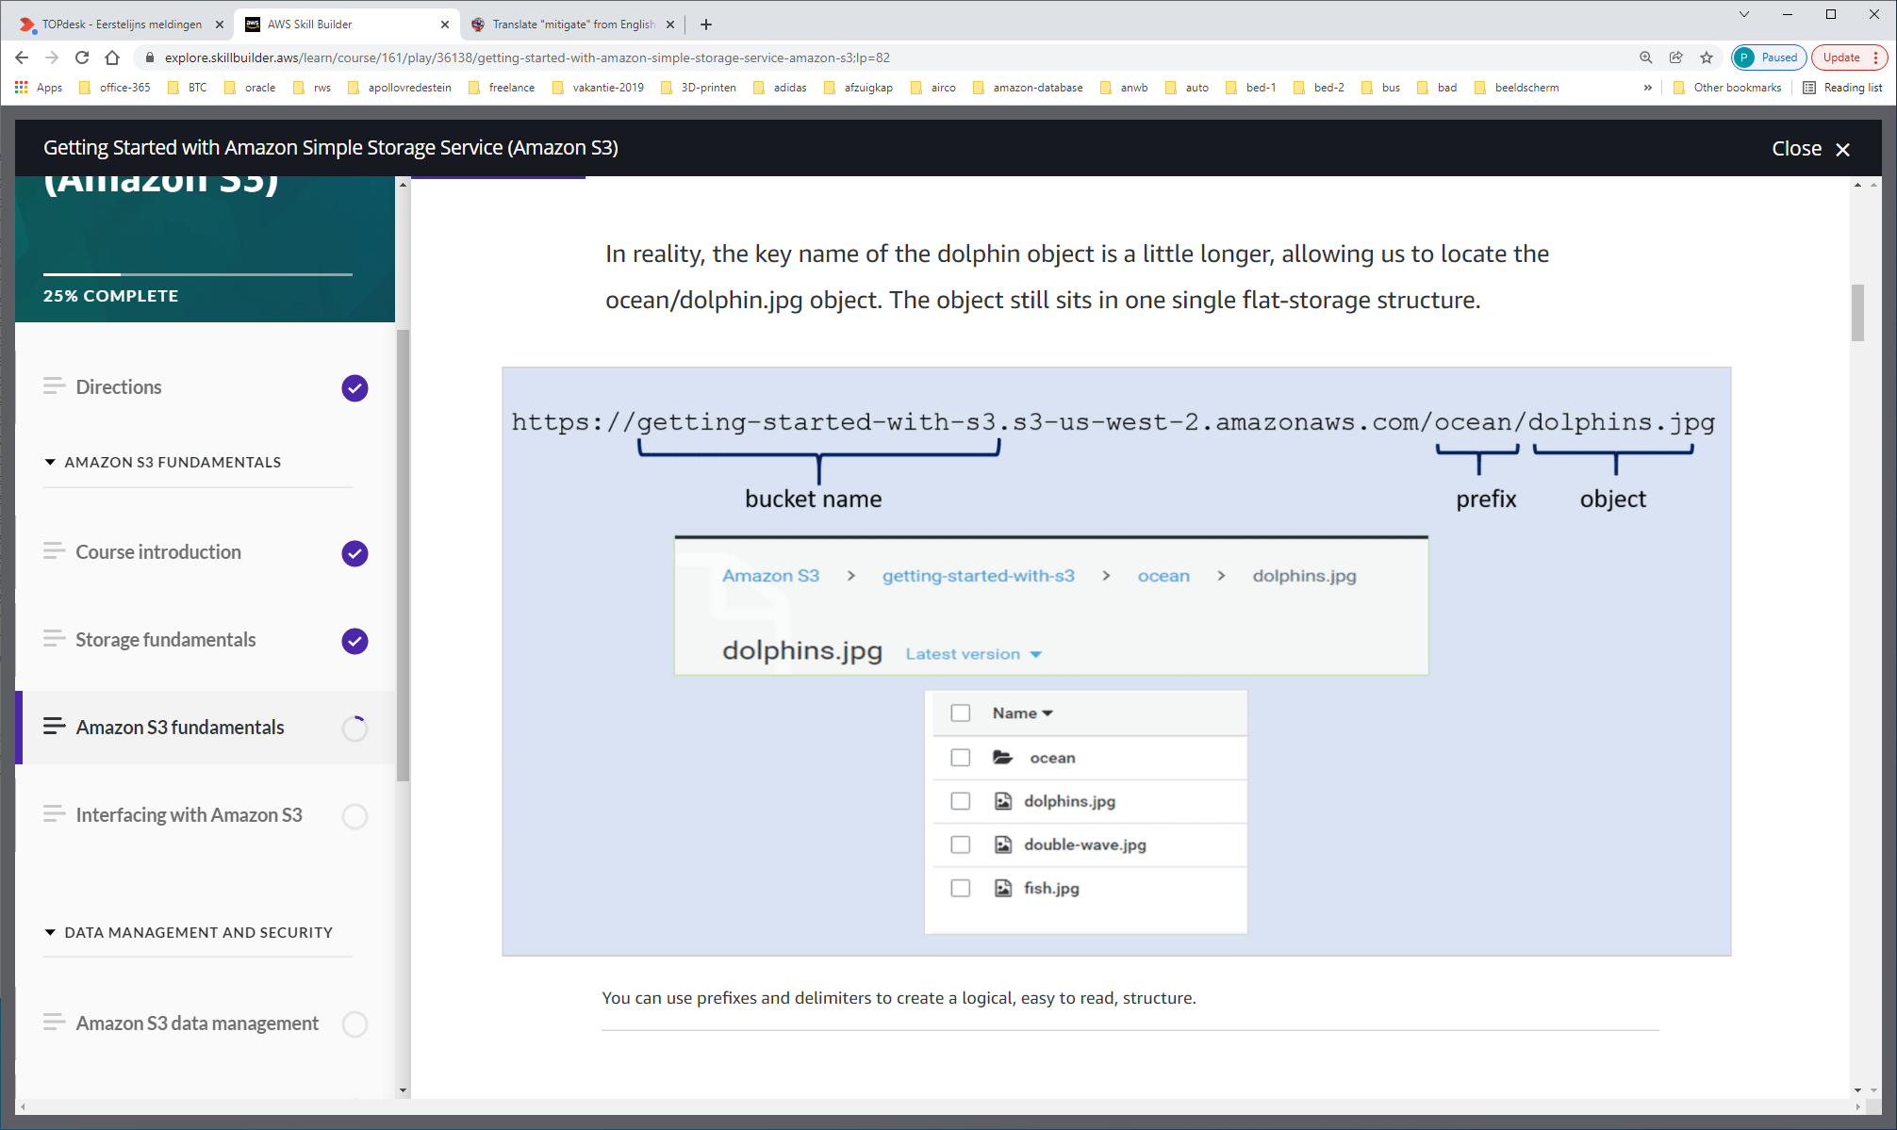

You can use prefixes to organize the data that you store in Amazon S3 buckets. A prefix value is similar to a directory name that enables you to group similar objects together in a bucket. When you programmatically upload objects, you can use prefixes to organize your data.

The prefix limits the results to only those keys that begin with the specified prefix. The delimiter causes a list operation to roll up all the keys that share a common prefix into a single summary list result.

The purpose of the prefix and delimiter parameters is to help you organize and then browse your keys hierarchically. To do this, first pick a delimiter for your bucket, such as slash (/), that doesn't occur in any of your anticipated key names. Next, construct your key names by concatenating all containing levels of the hierarchy, separating each level with the delimiter.

For example, if you were storing information about cities, you might naturally organize them by continent, then by country, then by province or state. Because these names don't usually contain punctuation, you might use slash (/) as the delimiter. The following examples use a slash (/) delimiter.

* Europe/France/Nouvelle-Aquitaine/Bordeaux
* North America/Canada/Quebec/Montreal
* North America/USA/Washington/Bellevue
* North America/USA/Washington/Seattle

If you stored data for every city in the world in this manner, it would become awkward to manage a flat key namespace. By using Prefix and Delimiter with the list operation, you can use the hierarchy you've created to list your data. For example, to list all the states in USA, set Delimiter='/' and Prefix='North America/USA/'. To list all the provinces in Canada for which you have data, set Delimiter='/' and Prefix='North America/Canada/'.

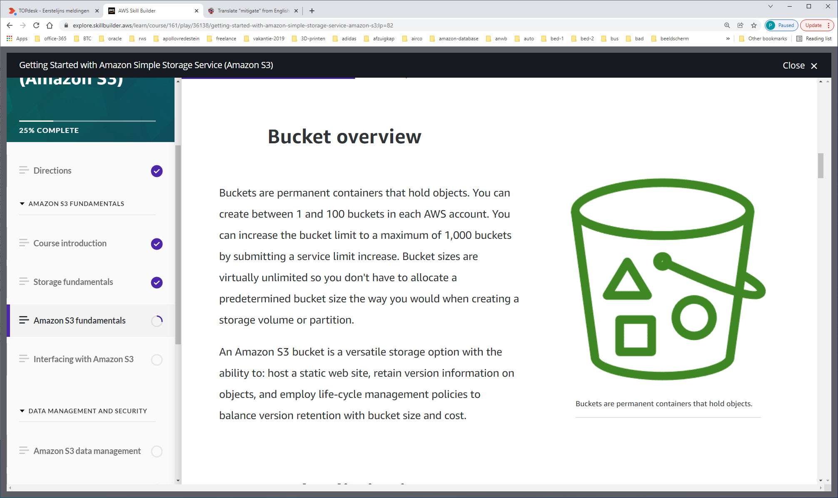

**Bucket limitations**

Prior to creating an Amazon S3 bucket, there are some important restrictions and limitations that you should know.

**Bucket owner**

Amazon S3 buckets are owned by the account that creates them and cannot be transferred to other accounts

**Bucket names**

Bucket names are globally unique.  There can be no duplicate names within the entire S3 infrastructure.

**Bucket renaming**

Once created, you cannot change a bucket name.

**Permanent entities**

Buckets are permanent storage entities and only removable when they are empty. After deleting a bucket, the name becomes available for reuse by any account after 24 hours if not taken by another account.

**Object storage limits**

There’s no limit to the number of objects you can store in a bucket. You can store all of your objects in a single bucket, or organize them across several buckets. However, you can't create a bucket from within another bucket, also known as nesting buckets.

**Bucket creation limits**

By default, you can create up to 100 buckets in each of your AWS accounts. If you need additional buckets, you can increase your account bucket limit to a maximum of 1,000 buckets by submitting a service limit increase.

When naming buckets, carefully determine how you want to structure your bucket names and how they will function. Will you use them only for data storage or hosting a static website? Your bucket names matter to S3, and based on how you use the bucket, your bucket names and characters will vary. Bucket names are globally viewable and need to be DNS-compliant.

Here are the rules to follow when naming your buckets. Bucket names must:

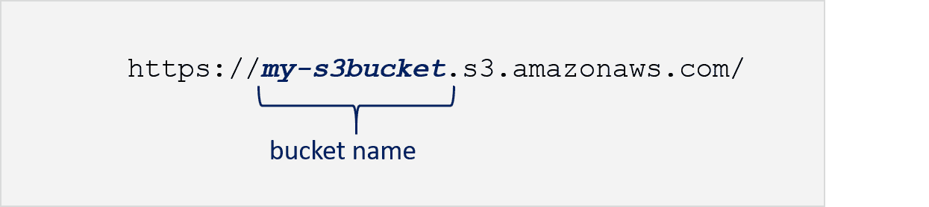

This identifies the bucket URL in the format of bucket name/ region endpoint.

* Be unique across all of Amazon S3
* Be between 3-63 characters long
* Consist only of lowercase letters, numbers, dots (.), and hyphens (-)
* Start with a lowercase letter or number
* Not begin with xn-- (beginning February 2020)
* Not be formatted as an IP address. (i.e. 198.68.10.2)
* Use a dot (.) in the name only if the bucket's intended purpose is to host an Amazon S3 static website; otherwise do not use a dot (.) in the bucket name

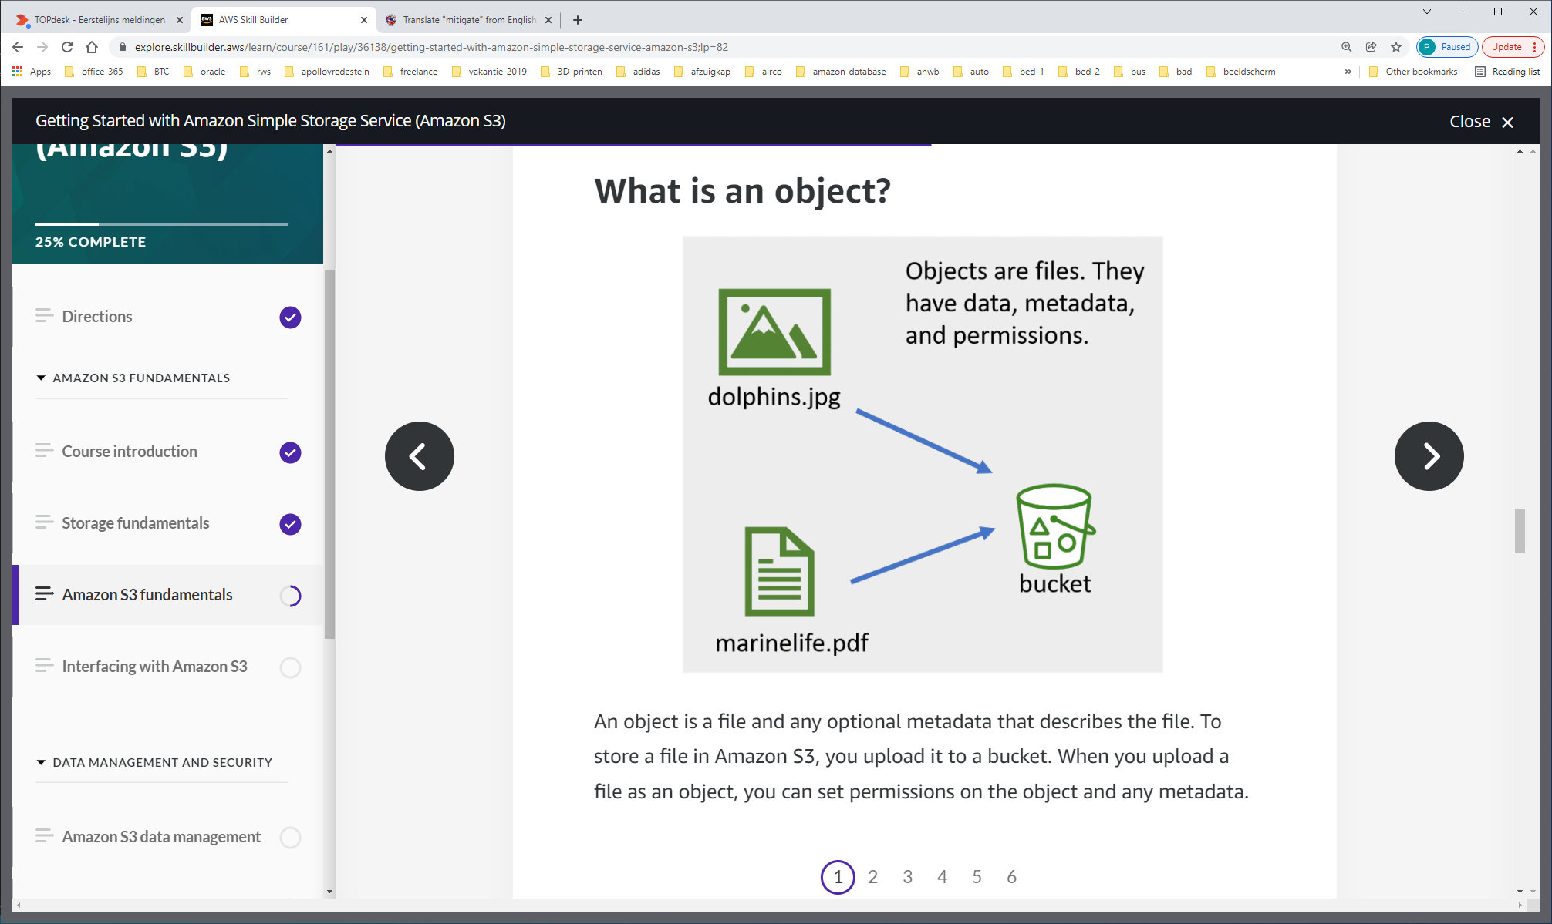

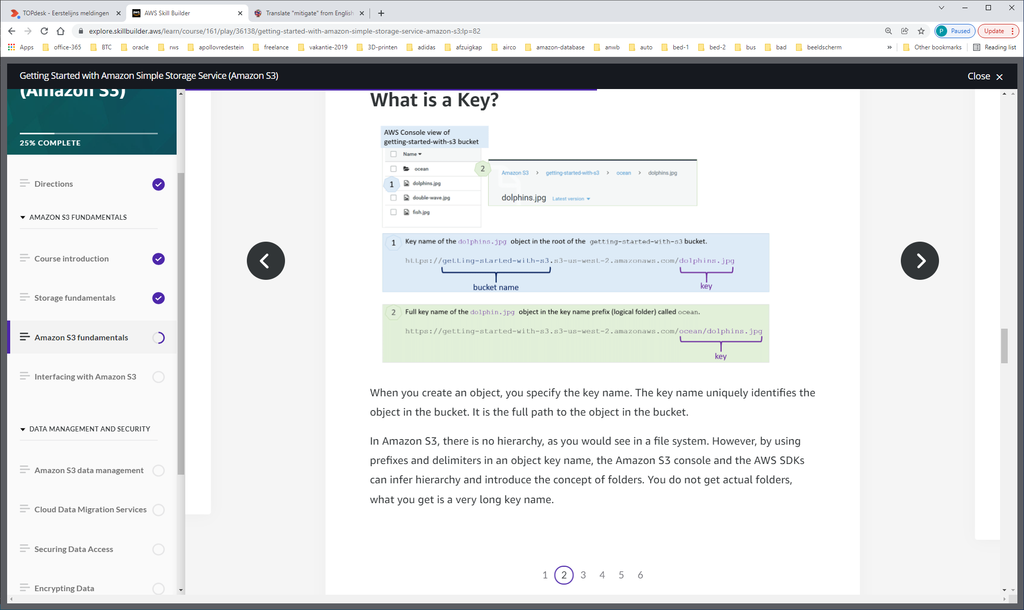

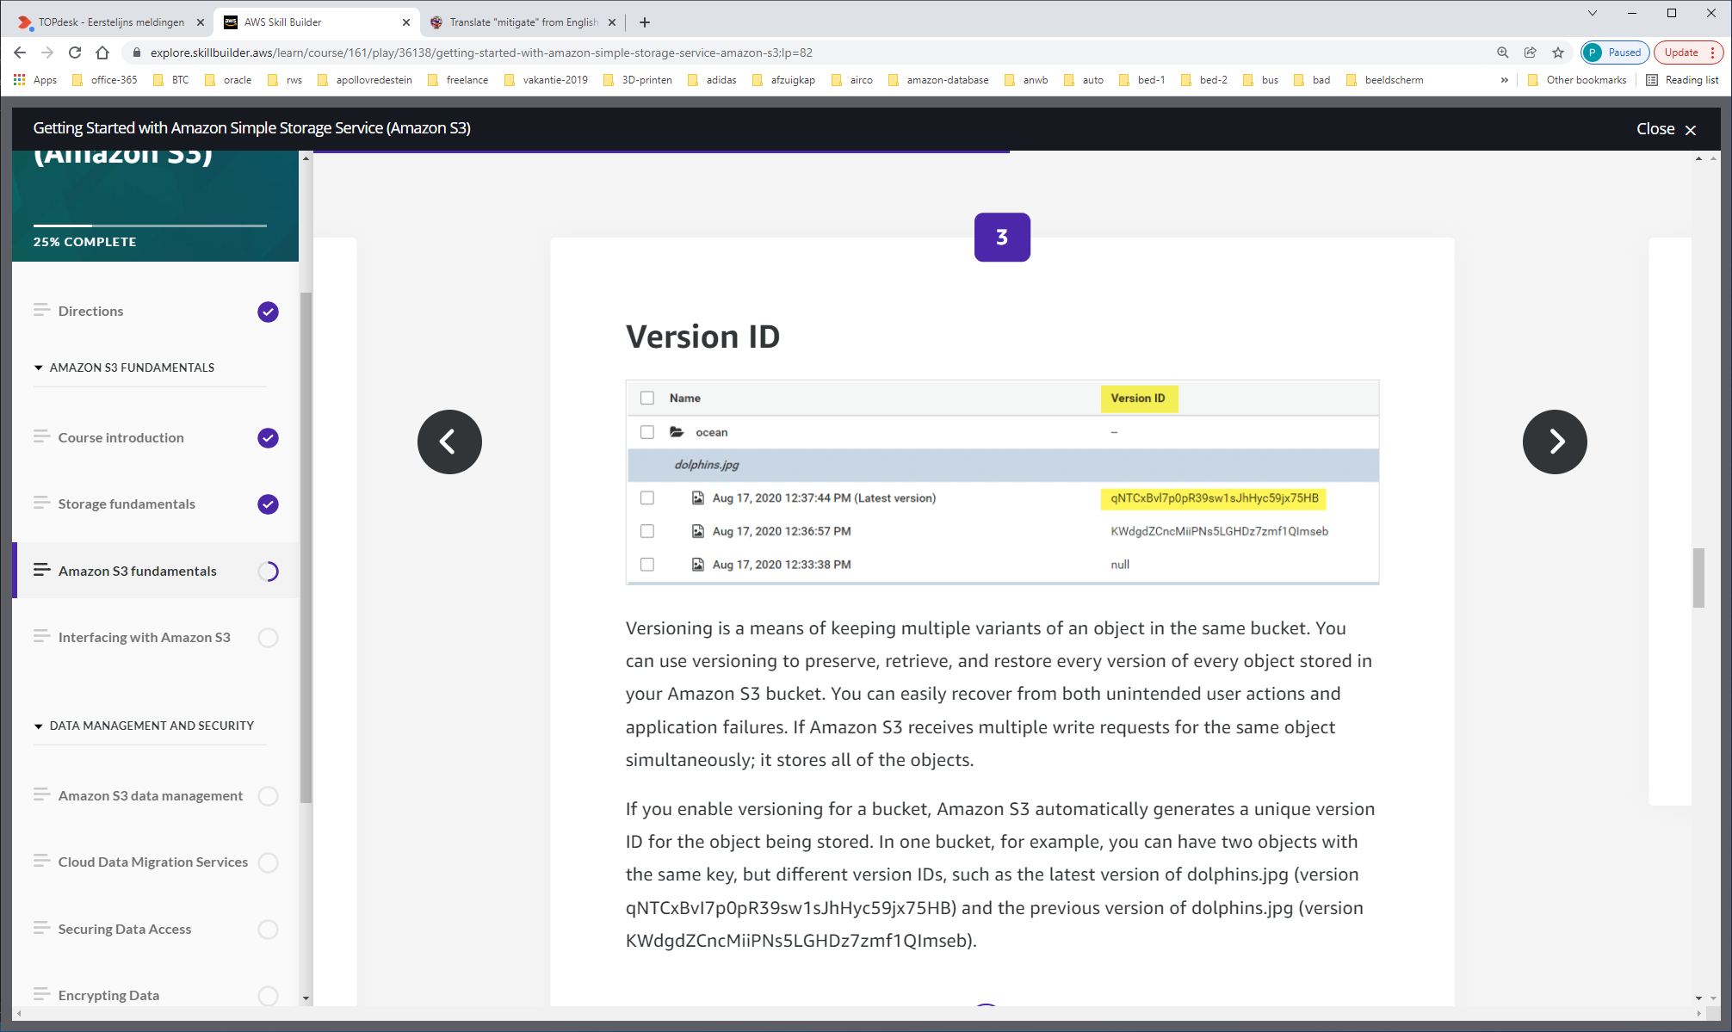

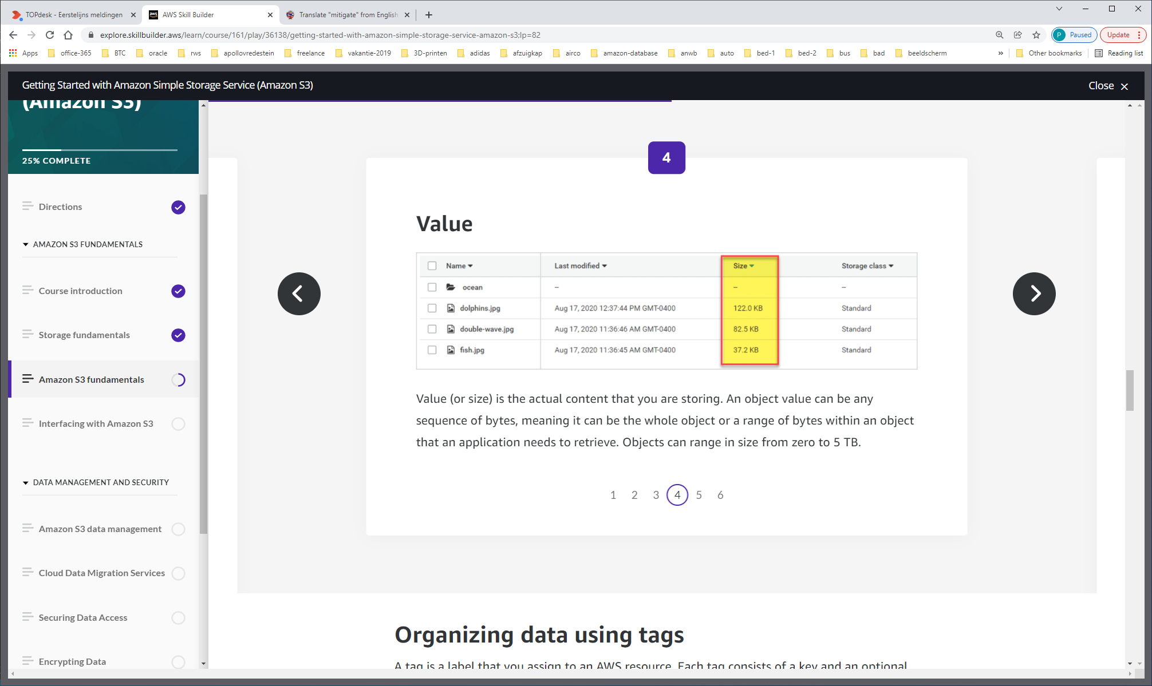

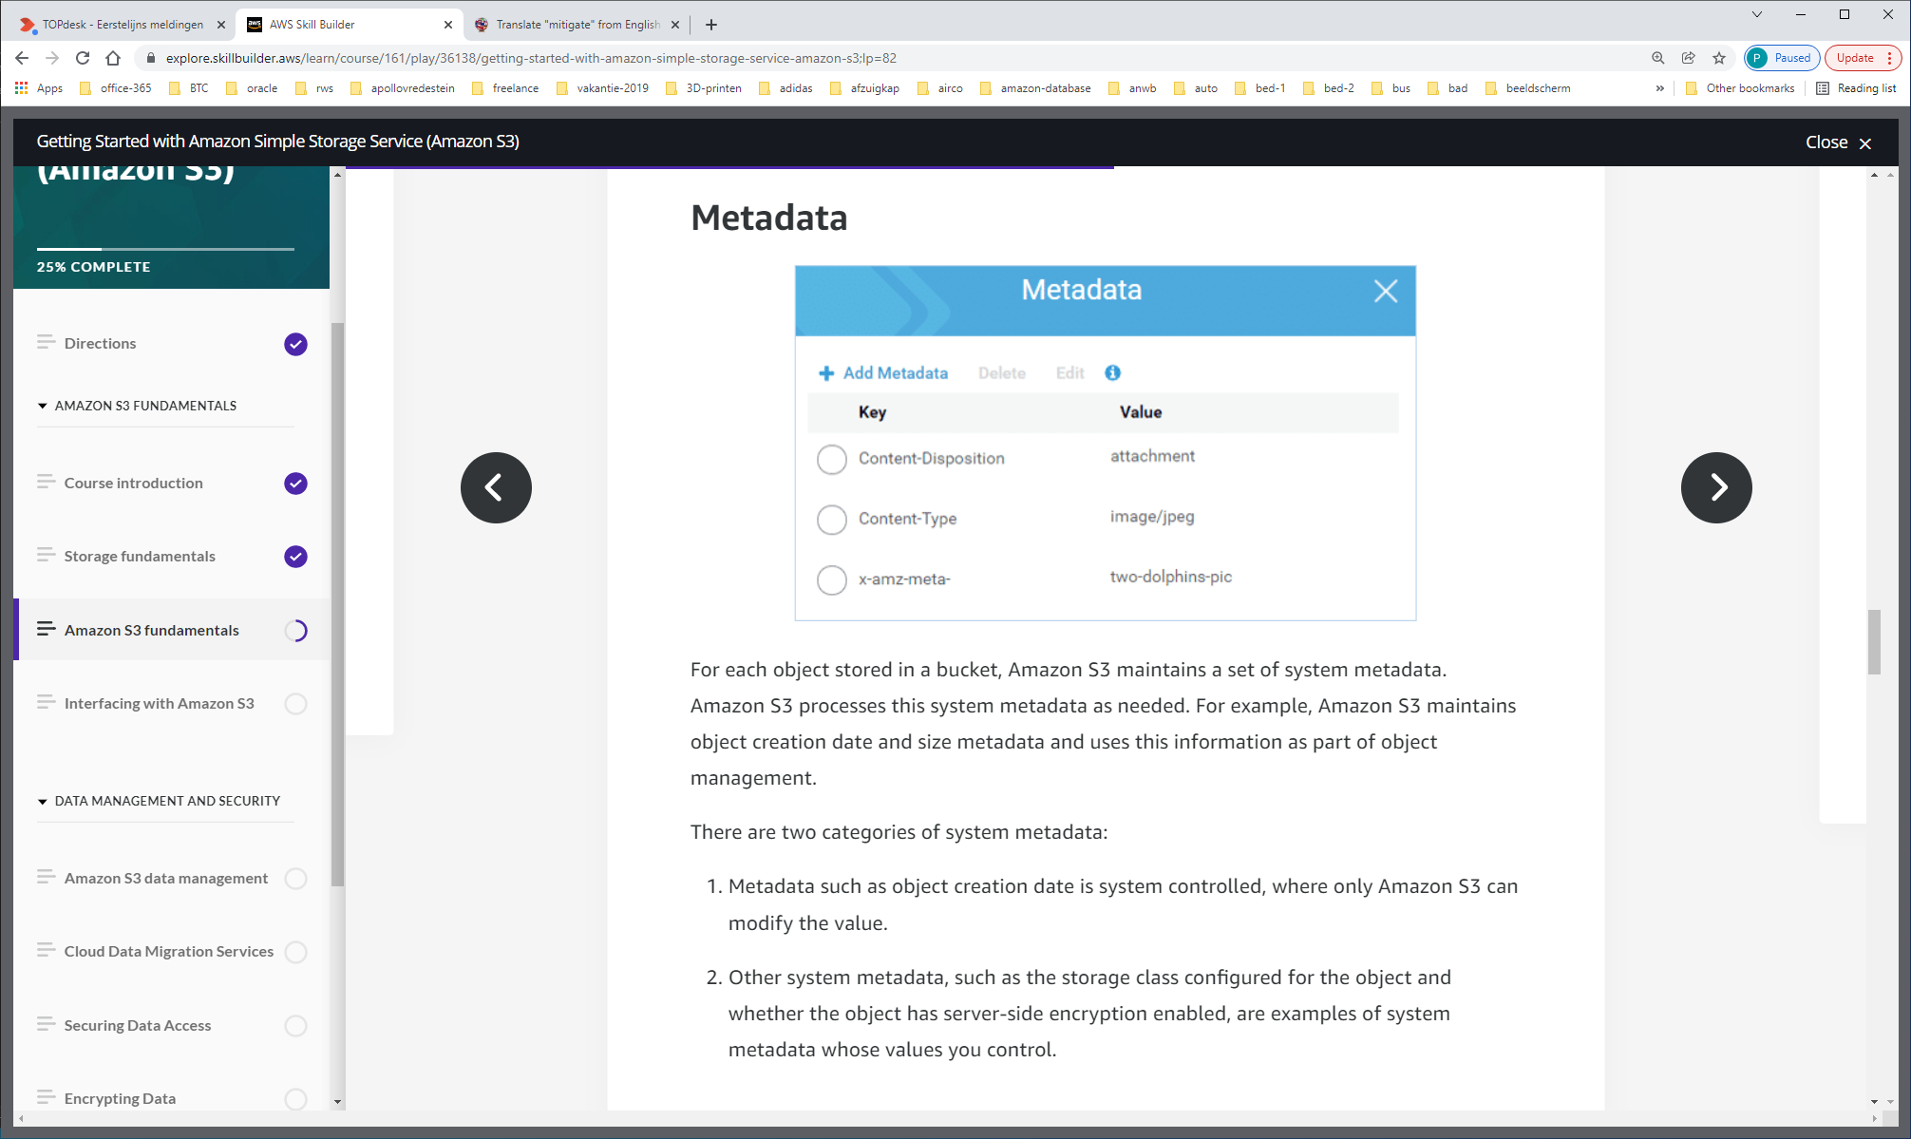

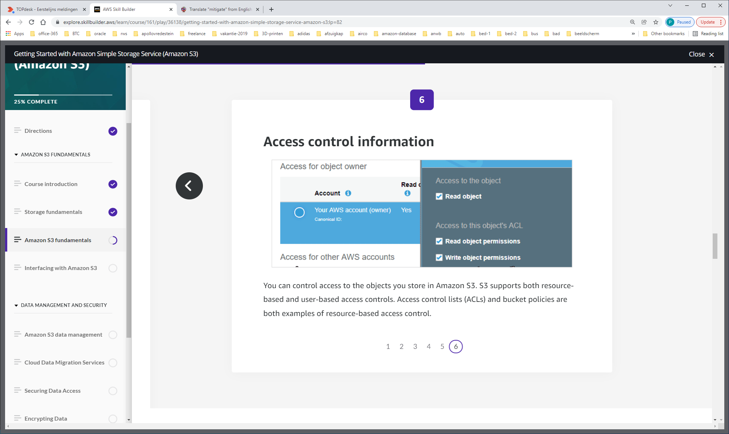

S3 supports both resource-based and user-based access controls.   
Access control lists (ACLs) and bucket policies are both examples of resource-based access control.

You can use two types of tags: Bucket tags and Object tags.

**Bucket tags**

Bucket tags allow you to track storage cost, or other criteria, by labeling your Amazon S3 buckets using cost allocation tags. A cost allocation tag is a key-value pair that you associate with an S3 bucket. After you activate cost allocation tags, AWS uses the tags to organize your resource costs on your cost allocation report. You can only use cost allocation tags on buckets and not on individual objects.

AWS provides two types of cost allocation tags, an AWS-generated tag and user-defined tag. AWS defines, creates, and applies the AWS-generated tag, createdBy, for you after an S3 CreateBucket event. You define, create, and apply user-defined tags to your S3 bucket.

Once you have created and applied the user-defined tags, you can activate them by using the Billing and Cost Management console for cost allocation tracking. Cost Allocation Tags appear on the console after enabling AWS Cost Explorer, AWS Budgets, AWS Cost and Usage reports, or legacy reports.

After you activate the AWS services, they appear on your cost allocation report. You can then use the tags on your cost allocation report to track your AWS costs.

**Bucket tag set**

Each S3 bucket has a tag set. A tag set contains all of the tags that are assigned to that bucket and can contain as many as 50 tags, or it can be empty. Keys must be unique within a tag set but values don't.

**Object tags**

Object tagging gives you a way to categorize and query your storage. You can add tags to an Amazon S3 object during the upload or after the upload. Each tag is a key-value pair that adheres to the following rules:

* You can associate up to 10 tags with an object they must have unique tag keys.
* Tag keys can be up to 128 characters in length
* Tag values can be up to 255 characters in length
* Key and tag values are case sensitive

**Additional benefits**

 Adding tags to your objects offer benefits such as the following:

* Object tags enable fine-grained access control of permissions. For example, you could grant an IAM user permission to read-only objects with specific tags.
* Object tags enable fine-grained object lifecycle management in which you can specify a tag-based filter, in addition to a key name prefix, in a lifecycle rule.
* When using Amazon S3 analytics, you can configure filters to group objects together for analysis by object tags, key name prefix, or both prefix and tags.
* You can also customize Amazon CloudWatch metrics to display information by specific tag filters. The next lesson provides more details.

**Object API operations for tagging**

With Amazon S3 tagging, if you want to add or replace a tag in a tag set (all the tags associated with an object or bucket), you must download all the tags, modify the tags, and then replace all the tags at once.

For more information, see the 'API operations related to object tagging' section in the following link:  <https://docs.aws.amazon.com/AmazonS3/latest/dev/object-tagging.html>

**Region location**

Amazon S3 is a globally viewable service. This means that in the AWS Management Console you do not have to specify a region in order to view the buckets. Remember that when you initially create the bucket, you must choose a region to indicate where you want the bucket data to reside. The region you choose should be local to your users or consumers to optimize latency, minimize costs, or to address regulatory requirements.

For example, if you reside in Europe, you will want to create buckets in the Europe (Ireland) or Europe (Frankfurt) regions rather than creating your buckets in Asia Pacific (Sydney) or South America (Sao Paulo). This way the data is closer to your users and consumers, reducing latency and ensuring regulatory and meets country legal requirements.

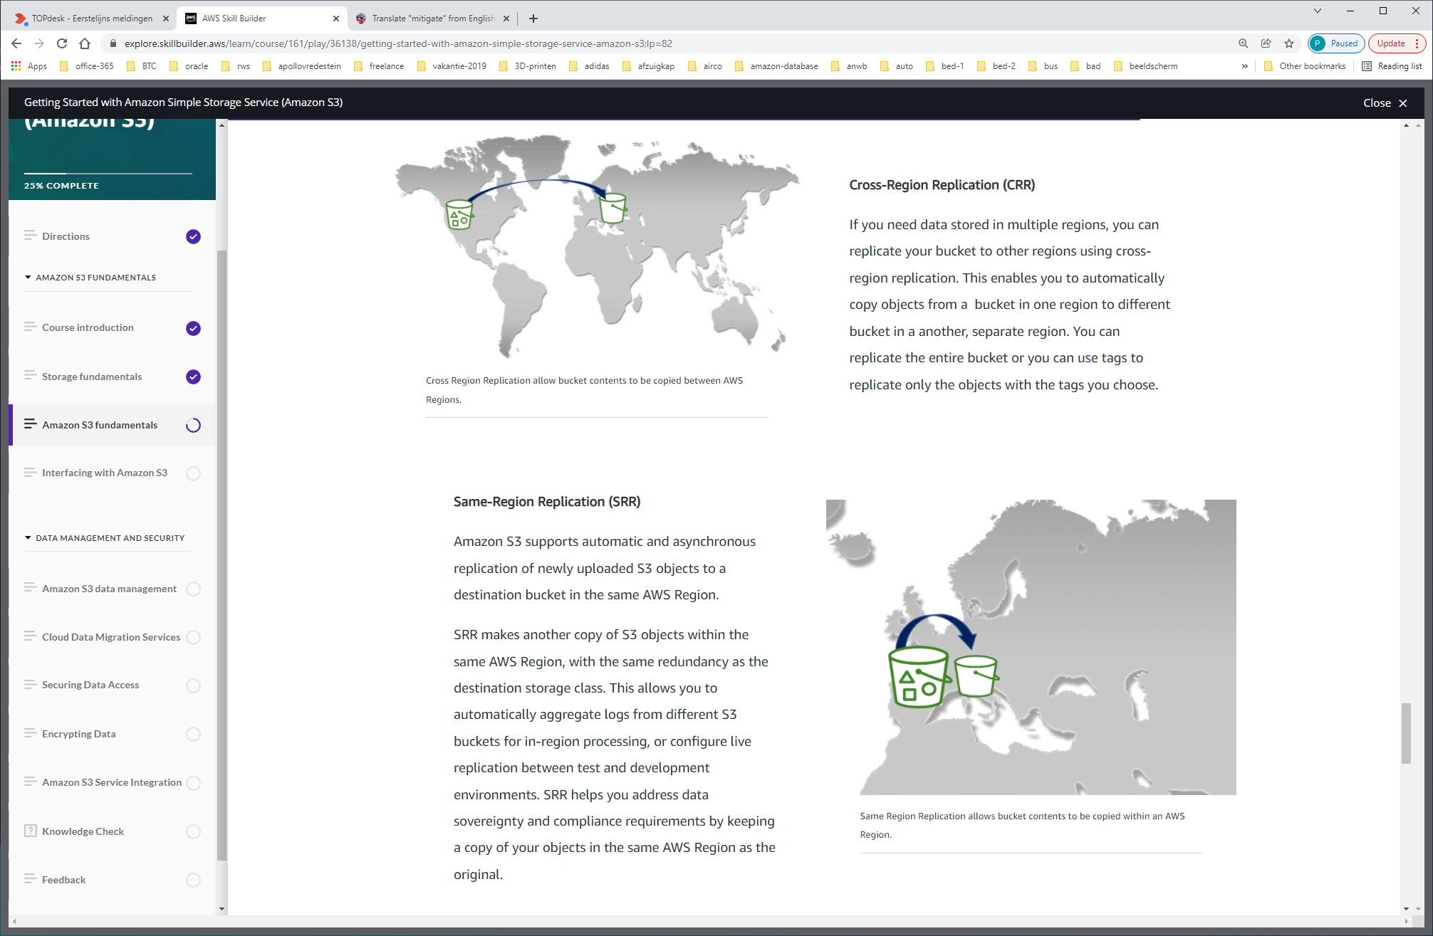

**Amazon S3 static websites**

You can use Amazon S3 to host a static website. With a static website, the individual web pages include only static content that does not change frequently. This is different from using a dynamic website, where the content is constantly changing and constantly updated. From the AWS Management Console, you can easily configure your bucket for static website hosting without needing to write any code.

**Interfacing with Amazon S3**

*Lesson 5 of 11*

Once you have a bucket created, there are multiple ways to add, overwrite, or retrieve objects in your Amazon S3 bucket. The three primary tools for interacting with buckets are

* the AWS Console,
* the AWS Command Line Interface (CLI),
* and using the AWS Software Development Kit (SDK).

The AWS Management Console provides a simple web interface to interact with AWS Services. You can log in using your AWS account name and password. If you’ve enabled AWS Multi-Factor Authentication, you will be prompted for your device’s authentication code.

Using the AWS Management Console for Amazon S3, you can view your buckets and objects, upload and download data, and manage permissions and security through the graphical user interface. You can also perform almost all bucket operations without having to write any code.

When uploading data via the AWS Management Console, the maximum file that you can upload is 160GB. To upload a file larger than 160 GB, use the AWS CLI, AWS SDK, or Amazon S3 REST API.

To learn more about the AWS Console features and functionality, follow this link:

<https://aws.amazon.com/console/features>

The AWS Command Line Interface (CLI) is a unified tool to manage your AWS services. The AWS CLI is used to manage your Amazon S3 data, buckets, and objects for users who prefer or require the functionality of the command line. You can manually upload, download, and manage your objects using the AWS CLI commands, or automate your processes using scripts. For more information on the AWS CLI follow this link: <https://docs.aws.amazon.com/cli/latest/userguide/cli-chap-welcome.html>

AWS SDK helps take the complexity out of coding by providing language specific groups of tools for building in AWS. You can simplify using Amazon S3 in your application with an API tailored to your programming language or platform. You can send authenticated requests to Amazon S3 either by using the AWS SDK or by making the REST API calls directly from your application.

You can easily develop applications on AWS in the programming language of your choice with familiar tools. There are a variety of SDKs to choose from to help you build solutions you need for your Amazon S3.

For more information on available AWS SDKs, follow this link: <https://aws.amazon.com/getting-started/tools-sdks/>

**Amazon S3 and REST API**

The REST API is an HTTP interface to Amazon S3. Using REST API, you use standard HTTP requests to create, fetch, and delete buckets and objects. You can use any toolkit that supports HTTP for use with the REST API. You can even use a browser to fetch objects, as long as they are anonymously readable.

Amazon S3 supports the REST API, which means that objects and buckets are resources, each with a URL that uniquely identifies the resource.

Addressing models are URLs that define how to locate data within an S3 bucket. Amazon S3 supports two types of addressing models: Path-style URLs and Virtual hosted style URLs.

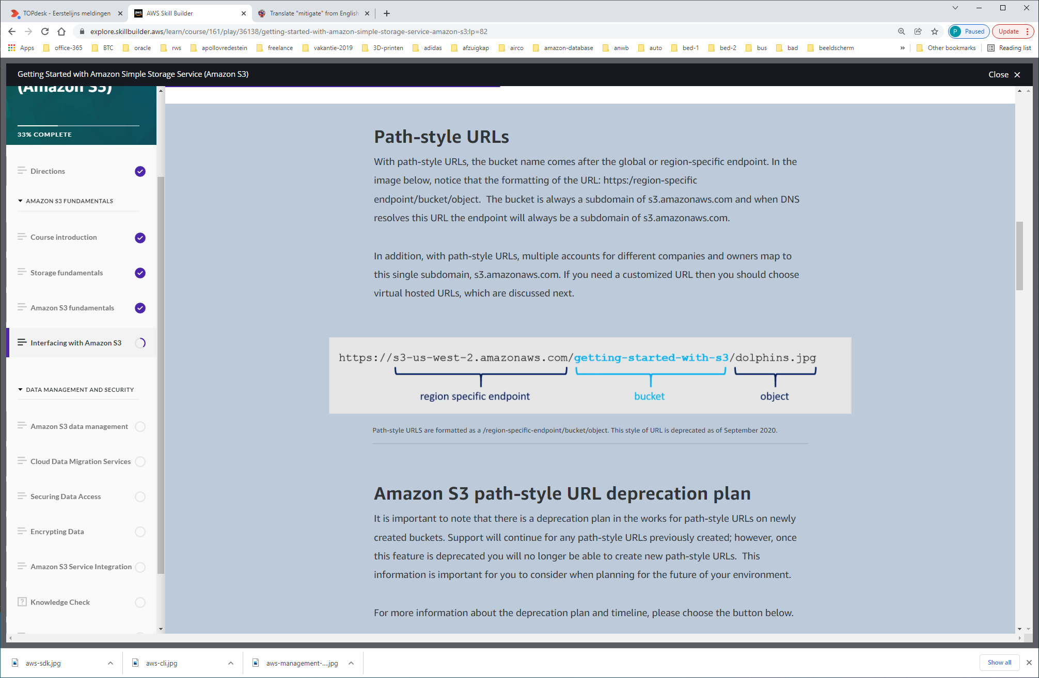

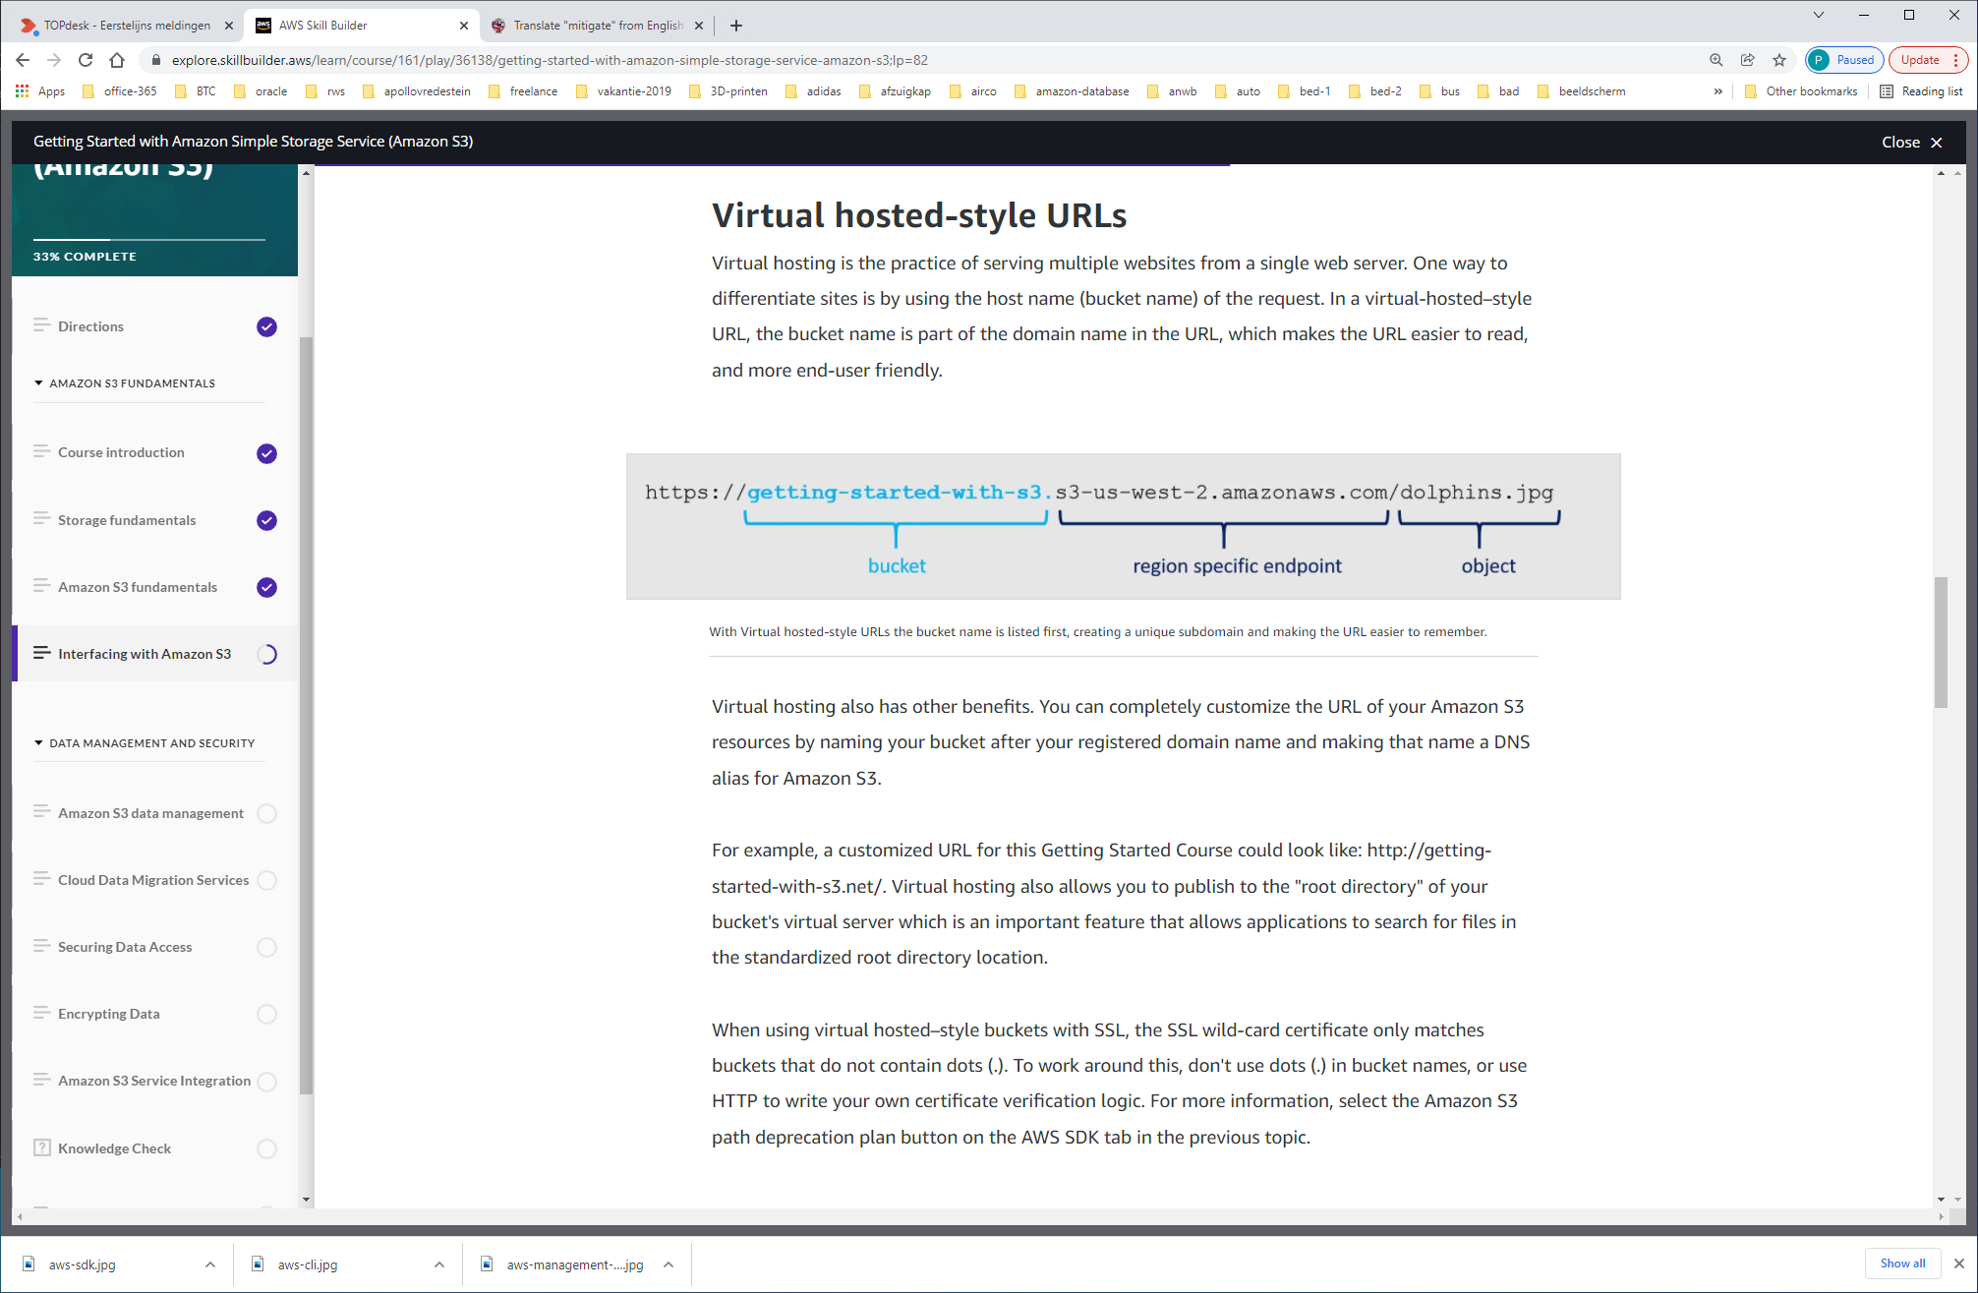

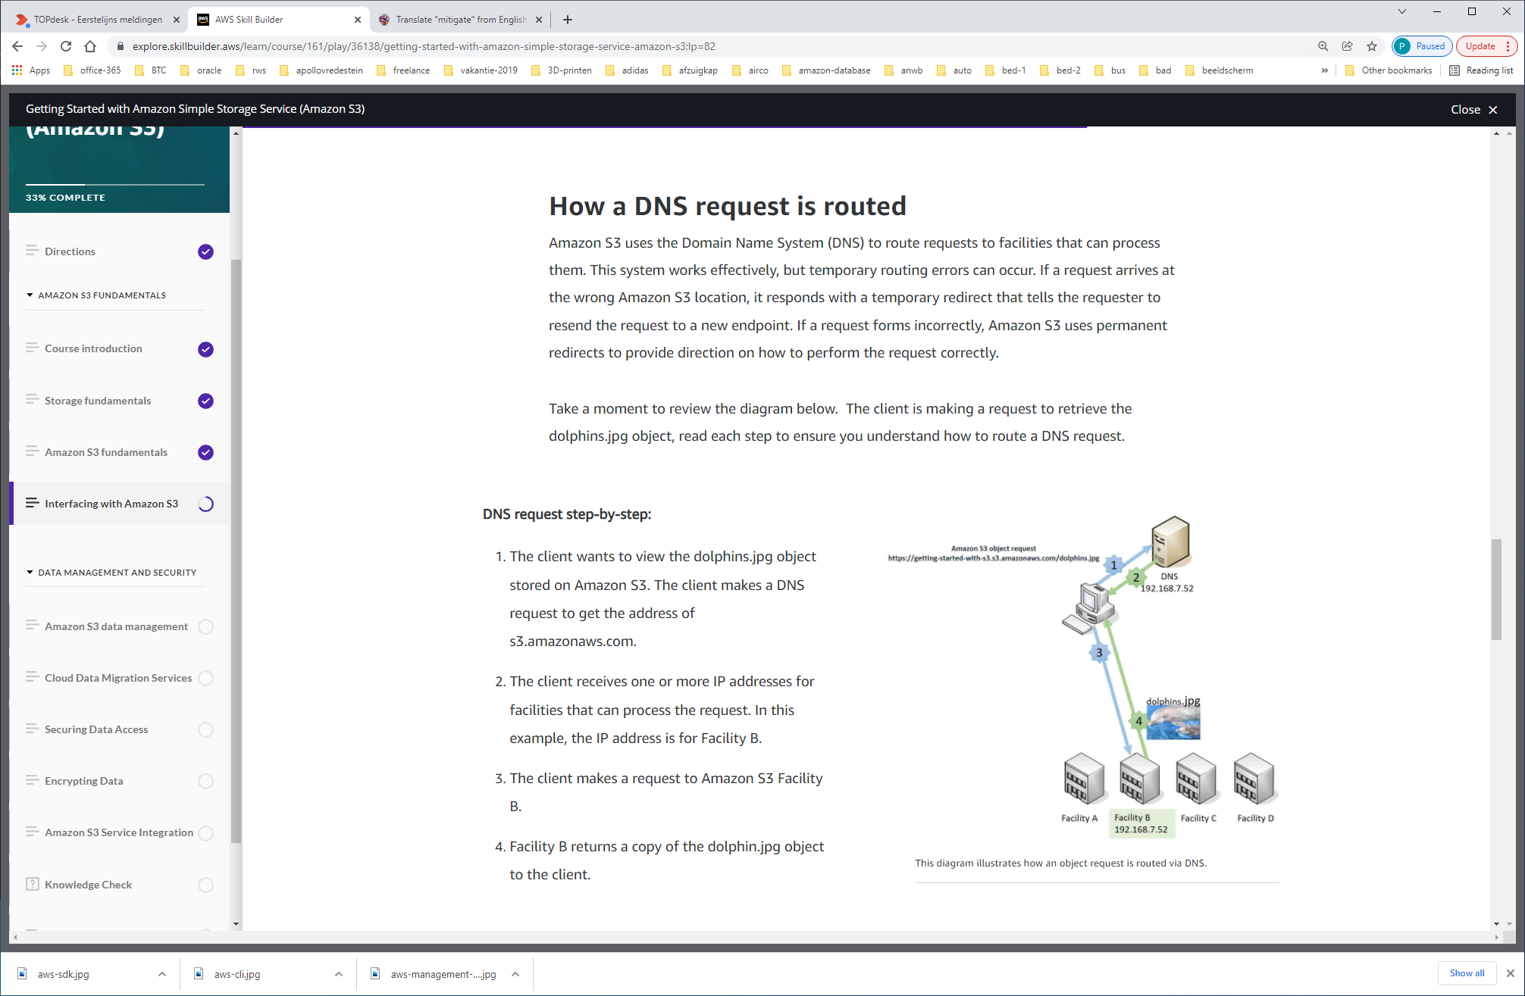

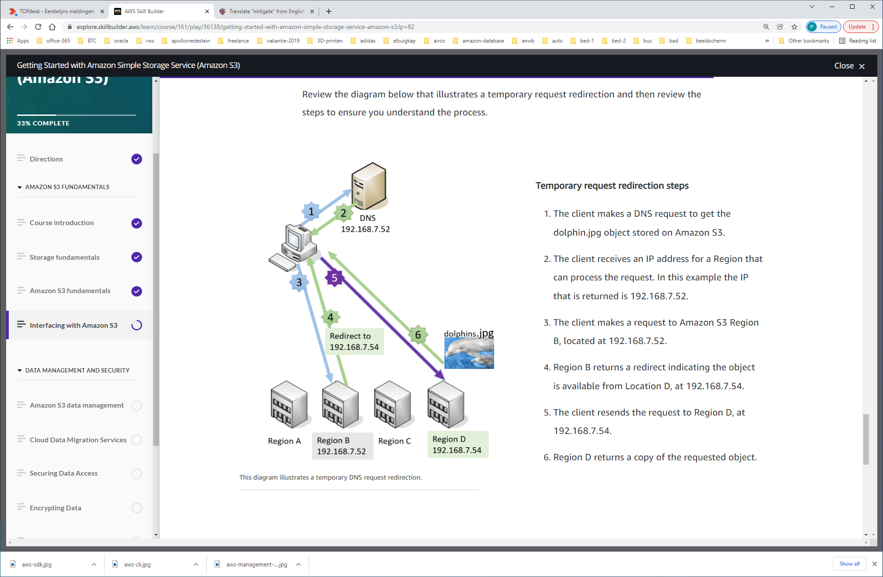

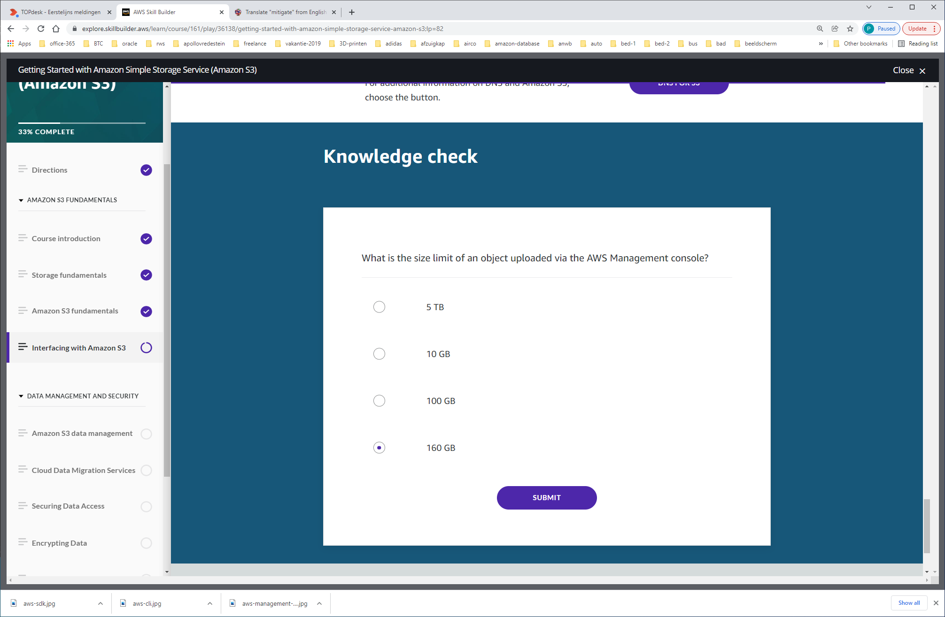

The first topic to explore is the **new Amazon S3 data consistency model** used when adding or modifying data to an S3 bucket.

**S3 Strong data consistency model**

Amazon S3 now delivers strong read-after-write consistency for any storage request, without changes to performance or availability, without sacrificing regional isolation for applications, and at no additional cost.  Any request for S3 storage is now strongly consistent.

After a successful write of a new object or overwrite of an existing object, any subsequent read request immediately receives the latest version of the object. Amazon S3 also provides strong consistency for list operations, so after a write, you can immediately perform a listing of the objects in a bucket with any changes reflected.

Why is this important? Previously, the Amazon S3 consistency model was strongly consistent for new objects and eventually consistent for modified or recently queried objects.  However, with the increased usage of high process analytics engines, applications and users need to have access to update data immediately after written. The strong read-after-write consistency model addresses the needs of large data lakes and applications that require immediate access to changed data.

There is no charge for this feature and it is available for all GET, PUT, LIST, HEAD requests, as well as Access Control Lists, object tags, and other metadata. For bucket operations such as reading a bucket policy or metadata, the consistency model remains eventually consistent.

**AWS Management Console**

The AWS Management Console is a graphical user interface that allows you to enable or disable versioning, view access logs, permissions and encryption, and manage all aspects of your buckets and objects though a friendly user interface. I gives you a secure login and management capabilities using your AWS or AWS Identity and Access Management (Identity and Access Management) account credentials, and allows you to enable AWS Multi-Factor Authentication for additional security.

You can personalize your AWS Management Console experience by creating shortcuts to the services you visit most often, like Amazon S3, by dragging and dropping the links onto the console’s top-level toolbar to create your shortcuts.

In addition to this, any login session that is not closed automatically expires after 12 hours. The console supports the three latest versions of Google Chrome, Mozilla Firefox, Microsoft Edge, and Apple Safari, as well as, Microsoft Internet Explorer 11. The AWS Management Console has a mobile app as well. With the mobile app, you can easily view your existing buckets and objects. The app also allows you to perform operational tasks.

You can use the AWS Management Console to manage the data properties, such as enabling versioning on your buckets. Let's talk about what versioning is and how it can help manage your data.

**Versioning**

Versioning is a means of keeping multiple variants of an object in the same bucket. You can use versioning to preserve, retrieve, and restore every version of every object stored in your Amazon S3 bucket. With versioning, you can easily recover from both unintended user actions and application failures.

If Amazon S3 receives multiple write requests for the same object simultaneously, and you enable versioning, it will store all of the object write requests.

If you enable versioning for a bucket, Amazon S3 automatically generates a unique version ID for the object being stored. In one bucket, for example, you can have two objects with the same key, but different version IDs, such as dolphins.jpg (version 111111) and dolphins.jpg (version 222222).

Versioning-enabled buckets enable you to recover objects from accidental deletion or overwrite. For example:

* If you delete an object, instead of removing it permanently, Amazon S3 inserts a delete marker, which becomes the current object version. You can always restore the previous version.
* If you overwrite an object, it results in a new object version in the bucket. You can always restore the previous version.

**Using the command line**

In Amazon S3 there are two types of commands you can use from the CLI:

* high-level commands
* and low-level commands.

 In this topic, you will cover both types of commands and resource links provided for additional reading material.

**High-level commands**

High-level commands simplify managing Amazon S3 objects from a command line. These commands enable you to manage the contents of Amazon S3 within itself and with local directories. You can identify the high-level commands because they begin with aws s3.

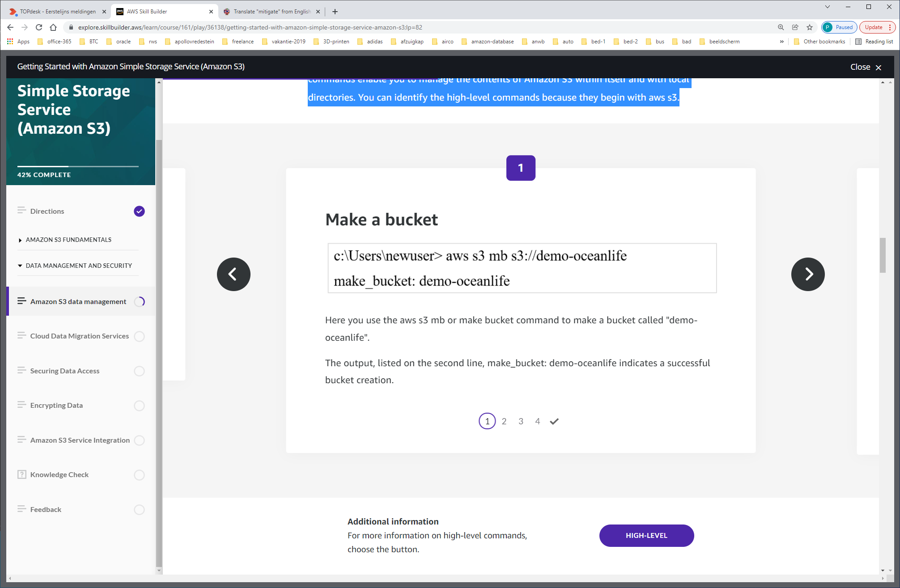

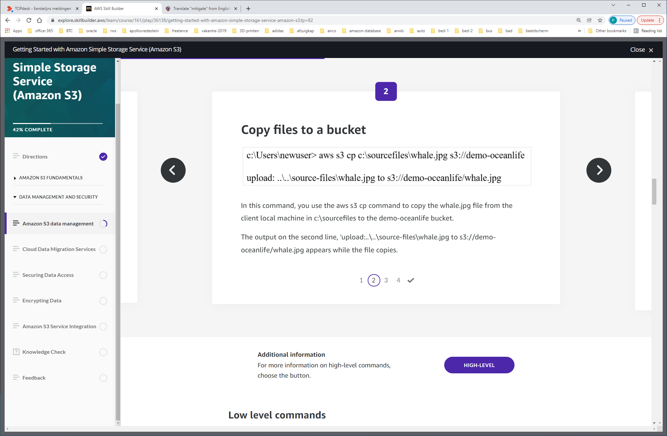

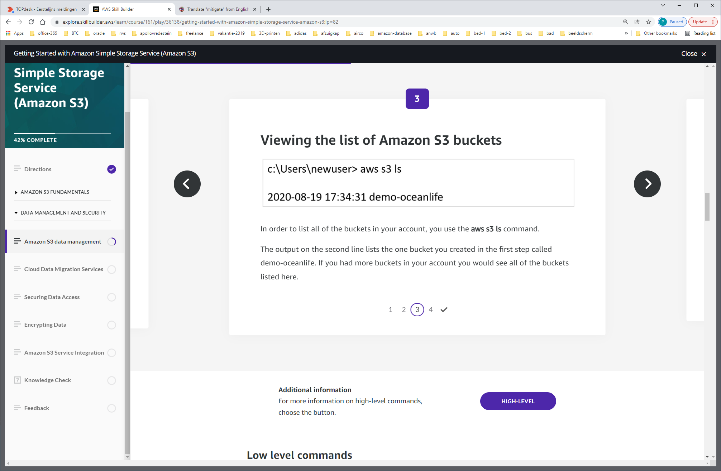

**aws s3 ls**

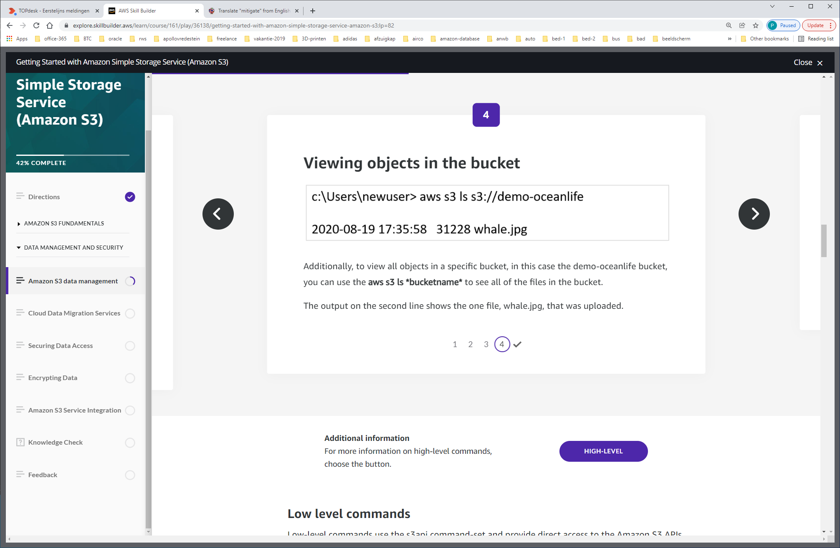

**aws s3 ls *bucketname\***

**Low level commands**

Low-level commands use the s3api command-set and provide direct access to the Amazon S3 APIs, enabling operations not exposed in the high-level s3 commands. Most of the the s3api commands are generated from JSON models that directly imitate the APIs of other AWS services that provide API-level access.

## **Prerequisites**

To run the s3api commands, you need to:

* AWS CLI installed, see [Installing or updating the latest version of the AWS CLI](https://docs.aws.amazon.com/cli/latest/userguide/getting-started-install.html) for more information.
* AWS CLI configured, see [Configuration basics](https://docs.aws.amazon.com/cli/latest/userguide/cli-configure-quickstart.html) for more information. The profile that you use must have permissions that allow the AWS operations performed by the examples.
* Understand these Amazon S3 terms:
  + **Bucket** – A top-level Amazon S3 folder.
  + **Prefix** – An Amazon S3 folder in a bucket.
  + **Object** – Any item that's hosted in an Amazon S3 bucket.

The **s3api list-objects** and **s3api make-bucket** commands share a similar operation name, input, and output as the corresponding operation in the Amazon S3 API. As a result, these commands allow a significantly more granular amount of control over your buckets when using the CLI.

**PUT operations**

Use the PUT request operation to add an object to a bucket. You must have WRITE permissions on a bucket in order to add an object. Amazon S3 never adds partial objects; if you receive a success response, you can be confident that the entire object was stored durably.

If the object already exists in the bucket, the new object overwrites the existing object. Amazon S3 orders all of the requests that it receives but it is possible that if you send two requests nearly simultaneously, the received requests will be in a different order than sent.

The last request received is the one which is stored. This means that if multiple parties are simultaneously writing to the same object, they may all get a success response even though only the last write wins. This is because Amazon S3 is a distributed system and it may take a few moments for one part of the system to communicate that another part has received an object update.

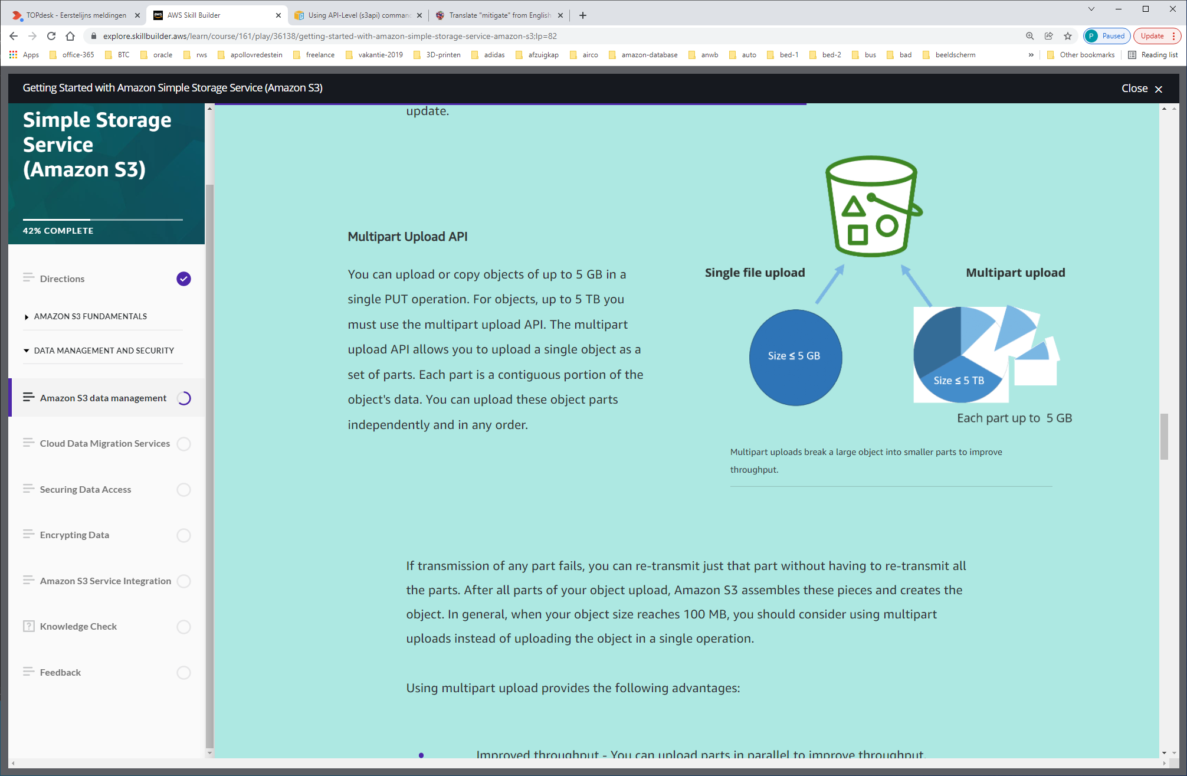

**Object lifecycle management**

When using multipart uploads, Amazon S3 retains all the parts on the server until you complete or discontinue the upload. To avoid unnecessary storage costs related to incomplete uploads, make sure to complete or discontinue an upload. Use lifecycle rules to clean up incomplete multipart uploads automatically.

An Amazon S3 Lifecycle configuration is an XML file that consists of a set of rules with predefined actions that you want Amazon S3 to perform on objects during their lifetime. As a best practice, we recommend you configure a lifecycle rule using the AbortIncompleteMultipartUpload action to minimize your storage costs.

It is recommended that you enable the ability to clean incomplete multipart uploads in the lifecycle settings even if you are not sure whether you are going to perform multipart uploads. Some applications default to multipart uploads when uploading files over a particular application-dependent size and failed or incomplete uploads will result in increased storage costs.

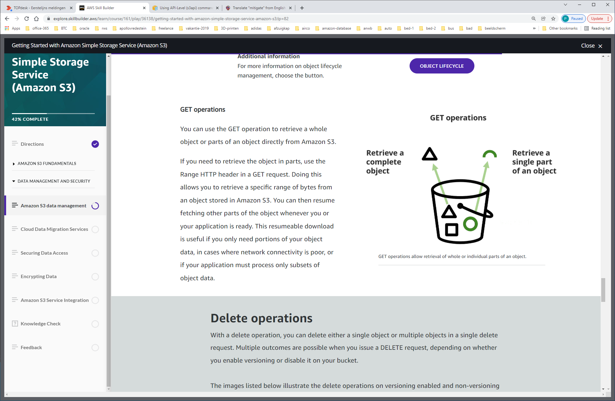

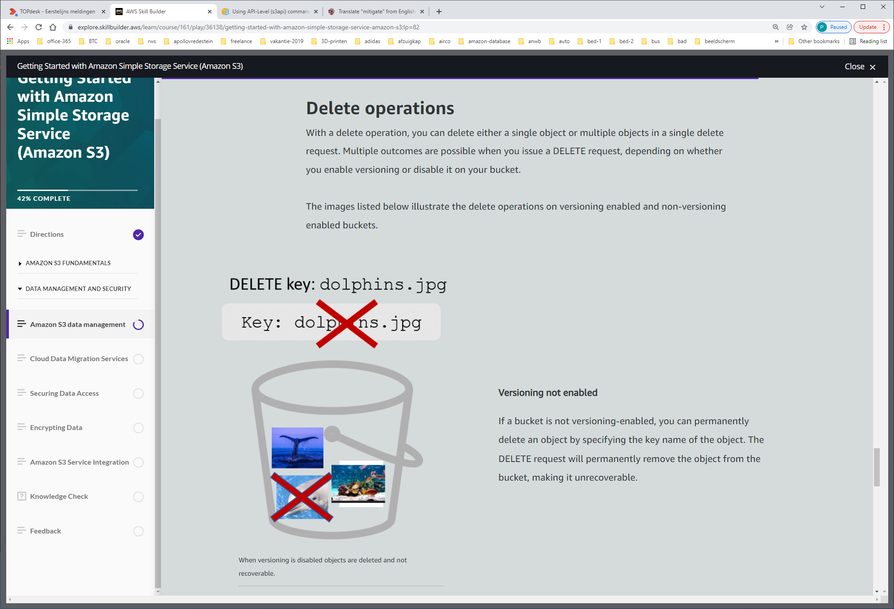

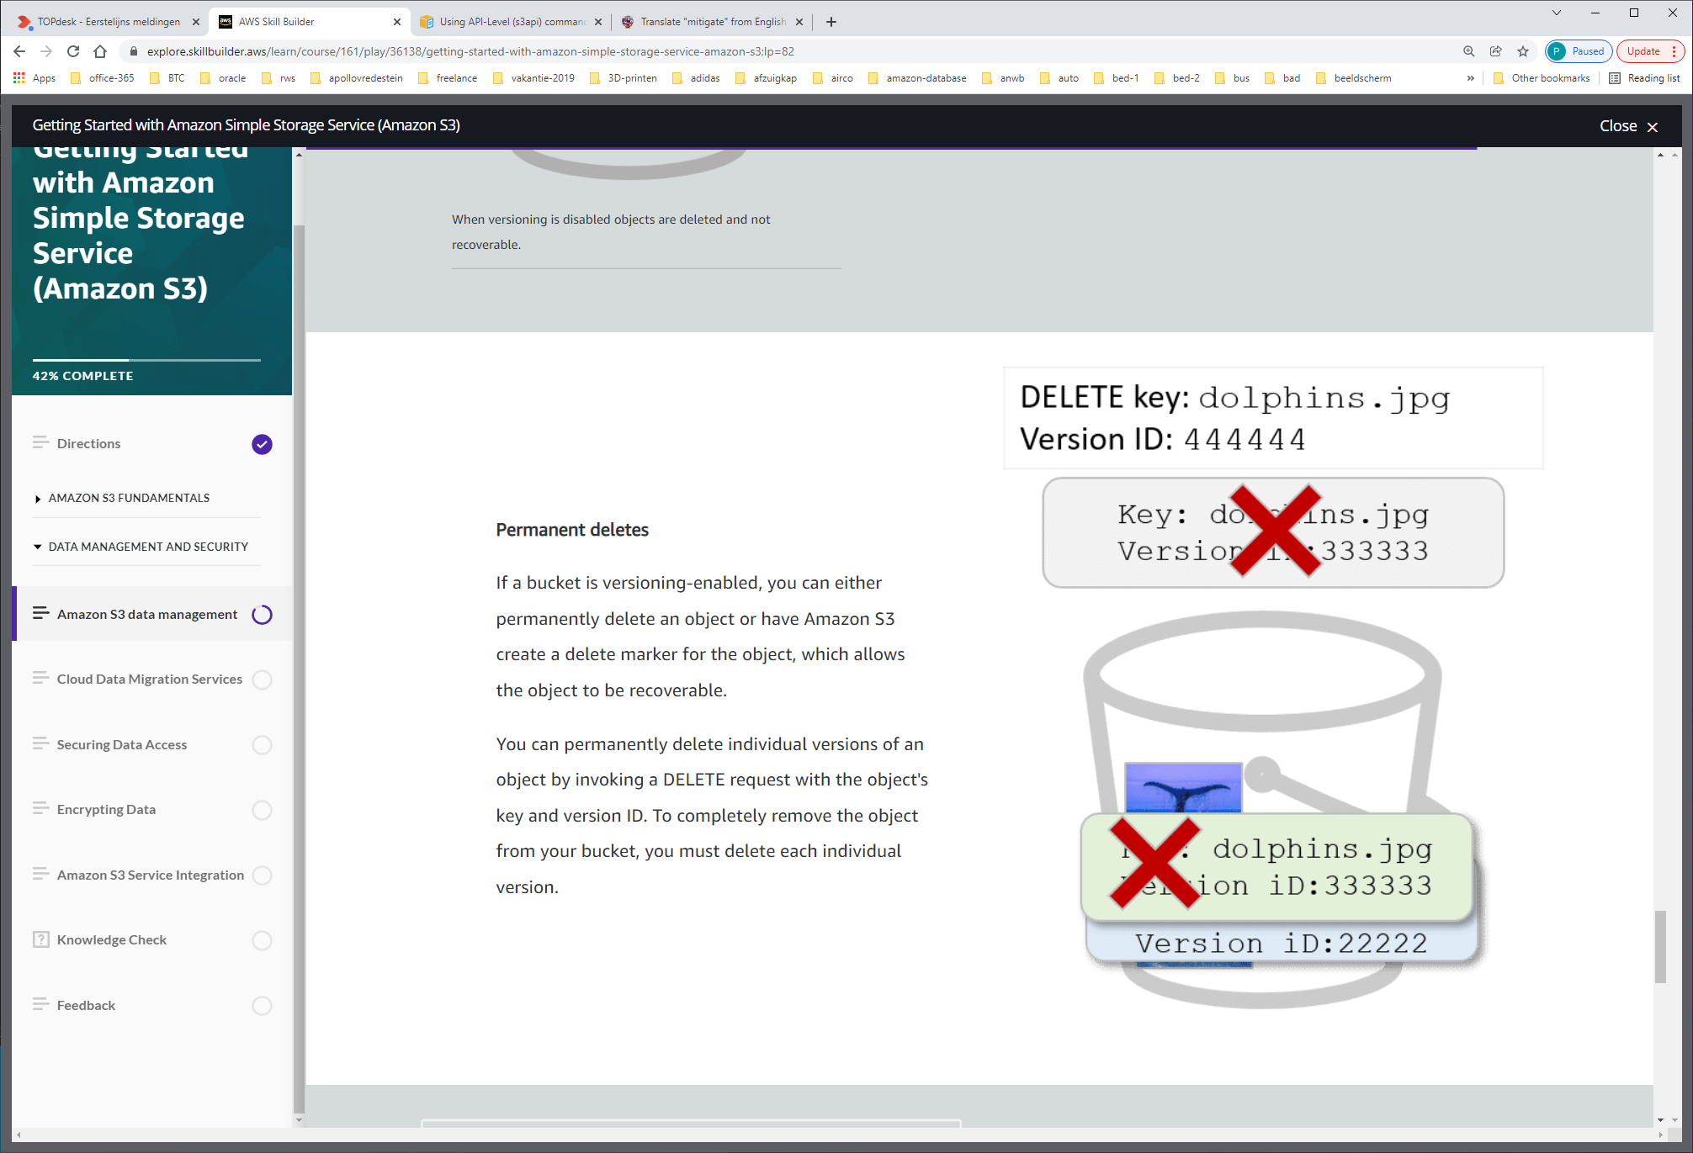

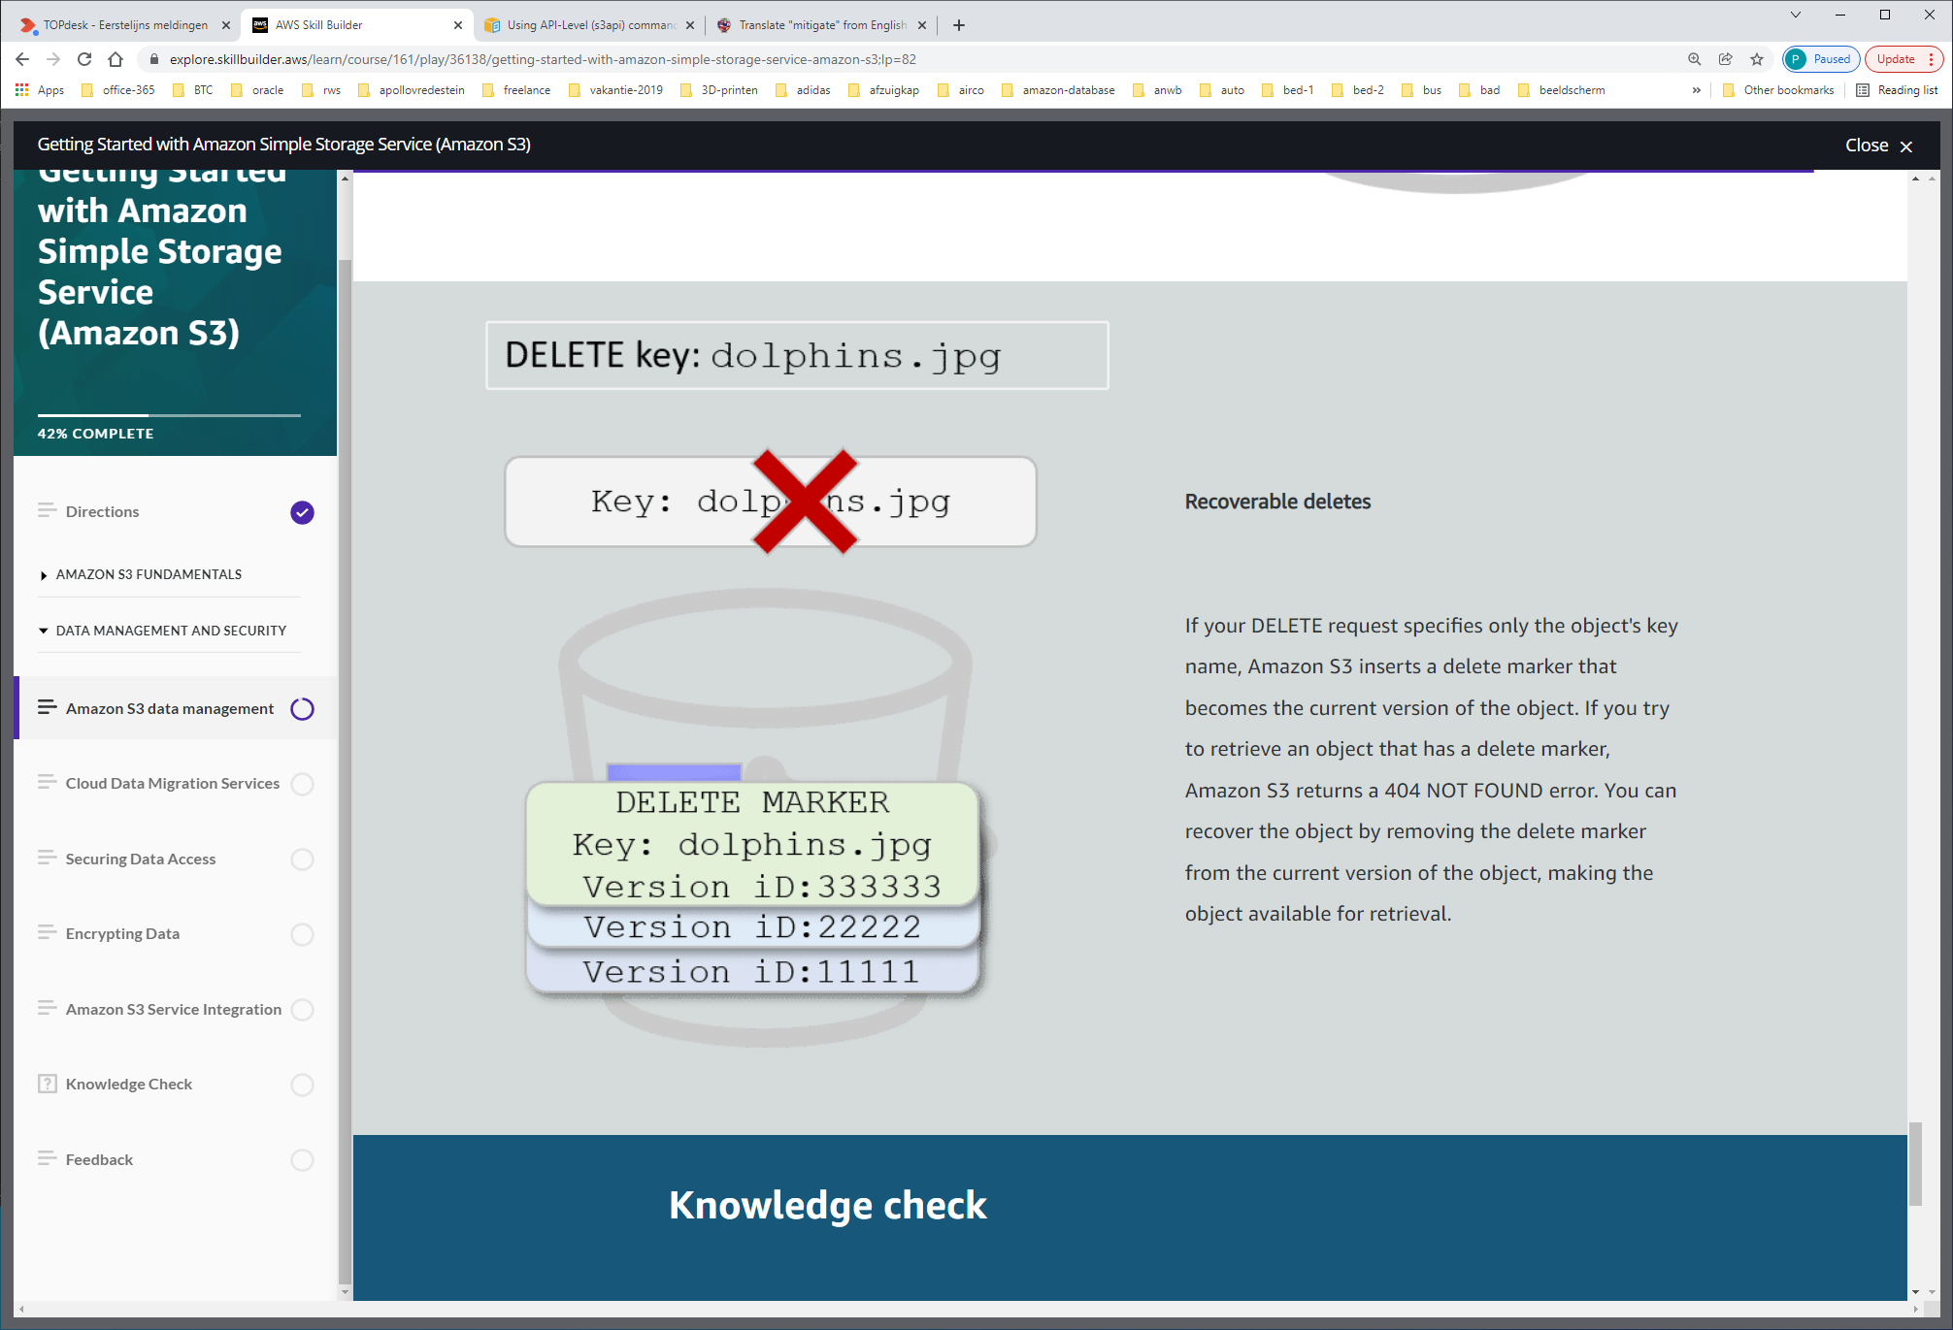

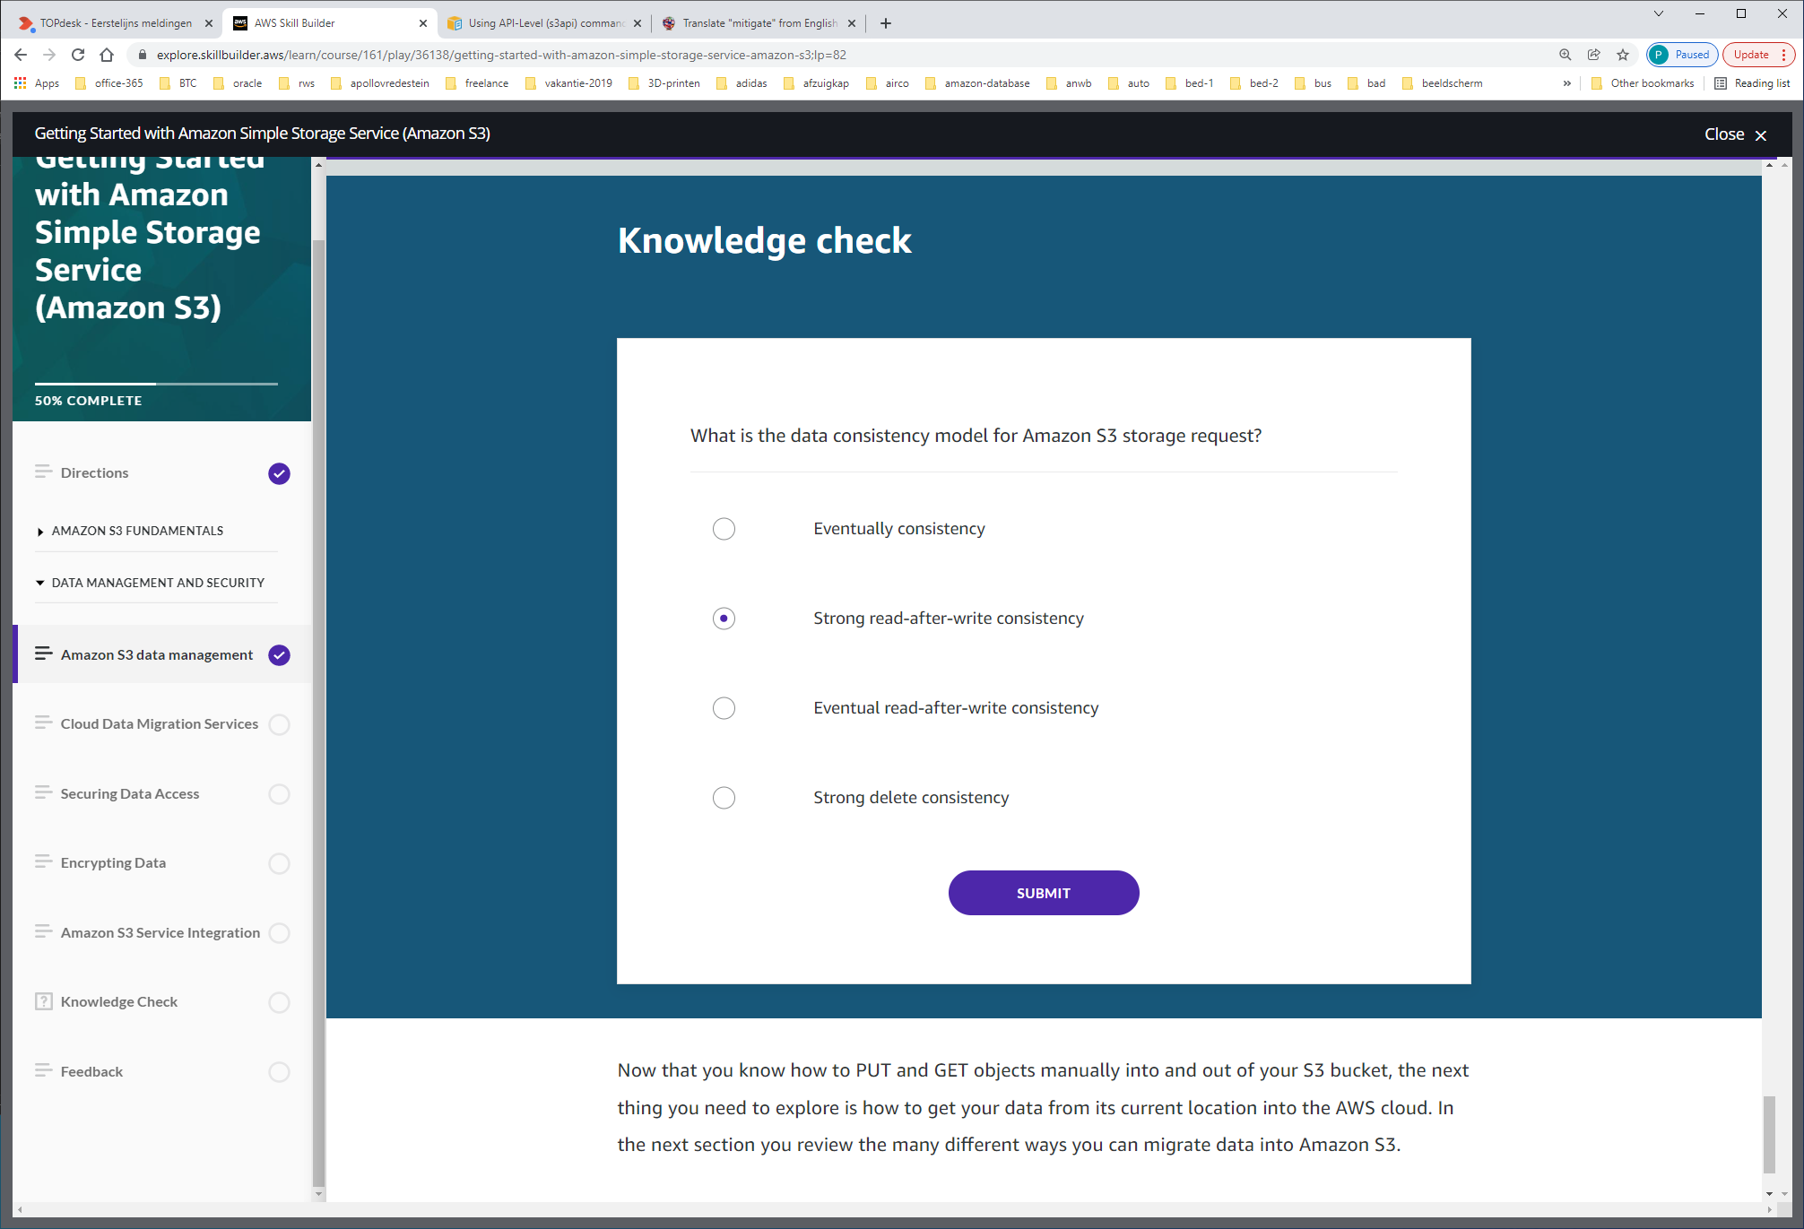

# Cloud Data Migration Services

*Lesson 7 of 11*

Data is a cornerstone of successful application deployments, analytics workflows, and machine learning innovations. When moving data to the cloud, you need to understand your different use cases, the types of data you are moving, and the network resources available. AWS offers a wide variety of services and partner tools to help you migrate your data sets, whether they are files, databases, machine images, block volumes, or even tape backups.

The portfolio of data transfer services provides the ideal solution for any data migration project. The level of online connectivity is a major factor in data migration, and AWS has offerings that can address your hybrid cloud storage, online data transfer, and offline data transfer needs.  In this lesson, we cover a high-level overview of the available migration tools.

**Online data transfer services**

Online data transfer services are a group of offerings that allows you to move your data into and out of the AWS Cloud and Amazon S3 via online, internet based, connections.

**AWS DataSync**

AWS DataSync makes it simple and fast to move large amounts of data online between on-premises storage and Amazon S3. DataSync manages many of the tasks related to data transfers that can slow down migrations. You can also reduce the burden of your IT operations, including running your own instances, handling encryption, managing scripts, network optimization, and data integrity validation.

DataSync can transfer hundreds of terabytes and millions of files at speeds up to 10 times faster than open-source tools. You can use it to migrate active data sets or archives to AWS, transfer data to the cloud for timely analysis and processing, or replicate data to AWS for business continuity.

For additional information on AWS Data Sync, select the following link:

<https://aws.amazon.com/datasync/?whats-new-cards.sort-by=item.additionalFields.postDateTime&whats-new-cards.sort-order=desc>

**AWS Transfer Family**

The AWS Transfer Family provides fully managed support for file transfers directly into and out of Amazon S3. The AWS Transfer Family helps you seamlessly migrate your file transfer workflows to AWS by integrating with existing authentication systems, and providing DNS routing with Amazon Route 53 so nothing changes for your customers and partners, or their applications. With your data in Amazon S3, you can use it with AWS services for processing, analytics, machine learning, and archiving.

For additional information on AWS Transfer Family, select the following link:

<https://aws.amazon.com/aws-transfer-family/?whats-new-cards.sort-by=item.additionalFields.postDateTime&whats-new-cards.sort-order=desc>

**Amazon S3 Transfer Acceleration**

You can use Amazon S3 Transfer Acceleration for fast, easy, and secure transfers of files over long distances. It takes advantage of Amazon CloudFront globally distributed edge locations, routing data to Amazon S3 over an optimized network path.

Transfer Acceleration is best suited for scenarios in which you want to transfer data to a central location from all over the world or transfer significant amounts of data across continents regularly. It can also help you use your available bandwidth when uploading to Amazon S3. For additional information on Amazon S3 Transfer Acceleration, select the following link: <https://aws.amazon.com/s3/transfer-acceleration/>

**Amazon Kinesis Data Firehose**

You can also stream data into Amazon S3 by using Amazon Kinesis Data Firehose, a fully managed streaming service. Because it captures and automatically loads streaming data in Amazon S3 and Amazon Redshift, you get near-real-time analytics with the business intelligence tools that you already use.

For additional information on Amazon Kinesis Data Firehose select the following link:

<https://aws.amazon.com/kinesis/data-firehose/?kinesis-blogs.sort-by=item.additionalFields.createdDate&kinesis-blogs.sort-order=desc>

**Amazon Kinesis Data Streams**

Amazon Kinesis Data Streams (KDS) enables you to build custom applications that process or analyze steaming data for specialized needs. Kinesis Data Streams can continuously capture and store terabytes of data per hour from hundreds of thousands of sources, such as website clickstreams, financial transactions, social media feeds, IT logs, and location -tracking events. You can also emit data from Kinesis Data Streams to other AWS services, such as Amazon S3, Amazon Redshift, Amazon EMR, and AWS Lambda.

For additional information on Amazon Kinesis Data Streams, select the following link:

<https://aws.amazon.com/kinesis/data-streams/>

**Amazon Partner Network**

You can use third-party connectors from the Amazon Partner Network for additional Amazon transfer service support. Amazon partners can help you move your data to the cloud. The simplest way to do that is through an embedded connection in your backup software. Using this approach, your backup catalog stays consistent so that you maintain visibility and controls across jobs that span disk, tape, and the cloud.

For additional information on Amazon Partner Network select the following link:

<https://aws.amazon.com/partners/>

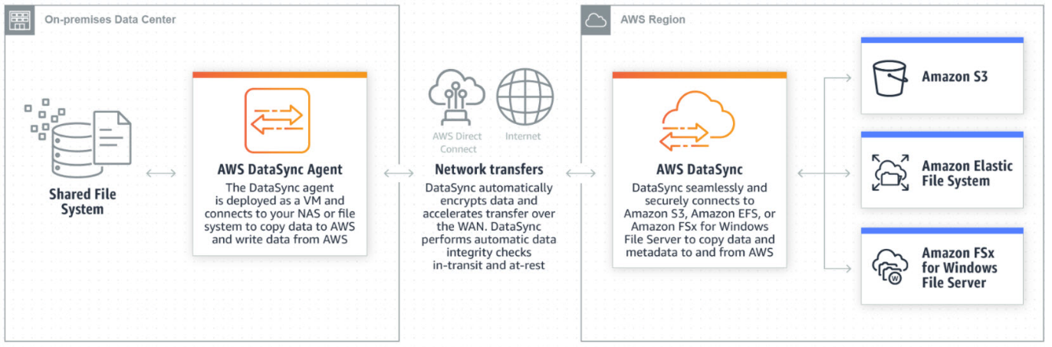

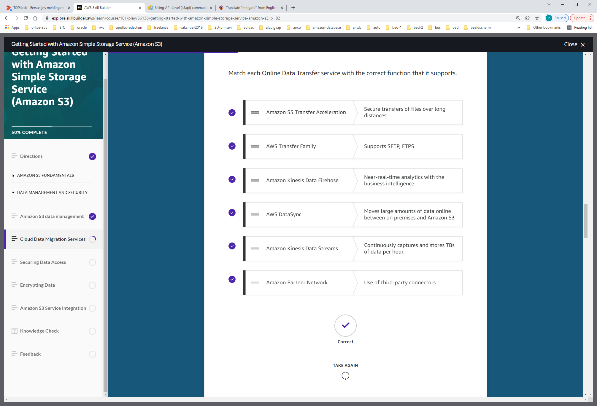

**Offline data transfer services**

Offline data transfer services use an alternate, physical storage method to move your data from remote locations to AWS. AWS Snowcone, AWS Snowball, and AWS Snowmobile are offline transfer services designed to transfer various quantities of data based on your business need.

Select the (+) symbol next to each member of the offline data transfer services that Amazon offers to learn more about your options when moving data into Amazon S3.

**AWS Snowcone**

AWS Snowcone is the smallest member of the AWS Snow Family of edge computing, edge storage, and data transfer devices, weighing in at 4.5 pounds (2.1 kg) with 8 terabytes of usable storage. You can run compute applications at the edge, and ship the device with data to AWS for offline data transfer, or you can transfer data online with AWS DataSync from edge locations.

Snowcone has multiple layers of security and encryption. You can use it to collect, process, and transfer data to Amazon S3. Snowcone is designed for data migration needs up to dozens of terabytes (with up to 8 terabytes per device) and from space-constrained environments where AWS Snowball devices will not fit.

For additional information on AWS Snowcone select the following link:

<https://aws.amazon.com/snowcone>

**AWS Snowball**

AWS Snowball is an edge computing, data migration, and edge storage device that comes in two options: Snowball Edge Storage Optimized and Snowball Edge Compute optimized.  
 Snowball Edge Storage Optimized devices provides both block storage and Amazon S3-compatible object storage, along with 40 vCPUs. Snowball Edge Compute Optimized devices provide 52 vCPUs, block and object storage, and an optional GPU for use cases like advanced machine learning and full motion video analysis in disconnected environments.

You can use these devices for data collection, machine learning and processing, and storage in environments with intermittent connectivity (like manufacturing, industrial, and transportation) or in extremely remote locations (like military or maritime operations) before shipping back to AWS. These devices may also be rack mounted and clustered together to build larger temporary installations.

For additional information on AWS Snowball select the following link:

<https://aws.amazon.com/snowball/>

**AWS Snowmobile**

AWS Snowmobile is an Exabyte-scale data transfer service used to move extremely large amounts of data to AWS. You can transfer up to 100PB per Snowmobile, a 45-foot long ruggedized shipping container, pulled by a semi-trailer truck.

Snowmobile uses multiple layers of security to help protect your data including dedicated security personnel, GPS tracking, alarm monitoring, 24/7 video surveillance, and an optional escort security vehicle while in transit. All data is encrypted with 256-bit encryption keys you manage through the AWS Key Management Service (KMS) and designed for security and full chain-of-custody of your data.

For additional information on AWS Snowmobile select the following link:

<https://aws.amazon.com/snowmobile/>

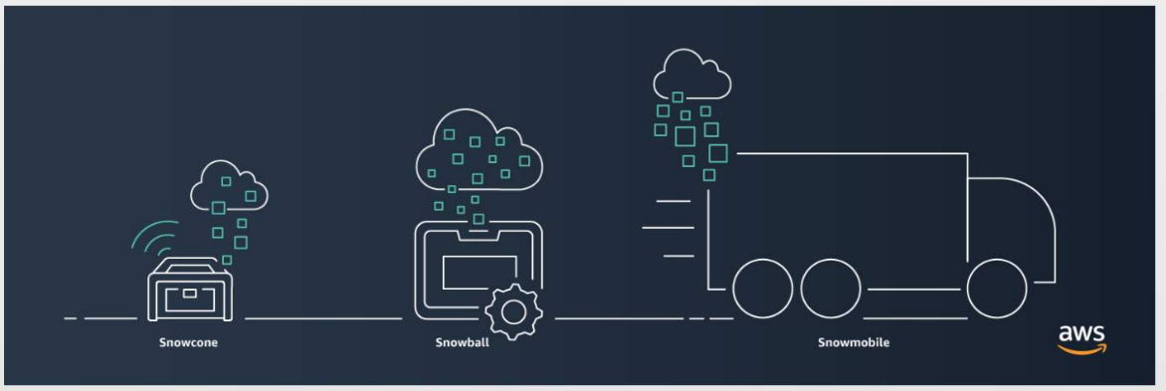

**Hybrid cloud storage services**

If you want to take advantage of the benefits of cloud storage but have applications running on-premises that require low-latency access to their data, or you need rapid data transfer to the cloud; then you can use AWS hybrid cloud storage architectures.

A hybrid storage strategy allows you to connect your on-premises applications and systems to cloud storage. This helps you reduce costs, minimize management burden, and innovate with your data.

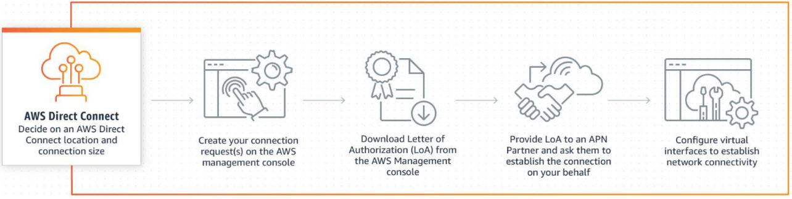

AWS Direct Connect gives you a dedicated network connection from your on-premises data center to AWS

**AWS Direct Connect**

AWS Direct Connect is a dedicated network connection from your on-premise data center to AWS. It provides a dedicated connection for higher throughput and secure data transfer without passing through the internet. Using industry standard 802.1q VLANs, this dedicated connection can be partitioned into multiple virtual interfaces.

For additional information on AWS Direct Connect select the following link:

<https://aws.amazon.com/directconnect/>

**AWS Storage Gateway**

You can use the AWS Storage Gateway, in File Gateway mode, to store your on premises data in an existing Amazon S3 bucket. You can deploy AWS Storage Gateway as a virtual appliance or purchase a hardware appliance version.

AWS Storage Gateway configured as a File Gateway enables you to connect your Amazon S3 bucket using either the Network File System (NFS) or Server Message Block (SMB) protocol with local caching. You can transfer your data using an AWS File Storage Gateway over the internet or over an AWS Direct Connect connection.

For additional information on AWS File Storage Gateway select the following link:

<https://aws.amazon.com/storagegateway/?whats-new-cards.sort-by=item.additionalFields.postDateTime&whats-new-cards.sort-order=desc>

**Unmanaged cloud data migration tools**

AWS also offers easy script or CLI tools to move data from your site into AWS cloud storage.

**rsync and 3rd party tools**

Depending your needs, you have the option to use rsync, an open source tool, along with other third-party file system tools to copy data directly into Amazon S3 buckets.

**Amazon S3 and the AWS CLI**

You can use the Amazon S3 and the AWS CLI to write commands and scripts that help you to move data directly into Amazon S3 buckets.

